ANKABUT Technical and Commercial Proposal for
Self-service portal for KUEC CoE customers
Khalifa University Enterprise Company (KUEC)
Submission Date: 19-Aug-2025

Statement of Confidentiality
THIS PROPOSAL IS CONSIDERED STRICTLY CONFIDENTIAL. IF YOU ARE NOT THE INTENDED RECIPIENT, OR THE INTENDED RECIPIENT’S AGENT, YOU ARE PROHIBITED FROM READING, USING, DISSEMINATING, DISTRIBUTING AND/OR COPYING THIS DOCUMENT. IN ACCESSING THE DOCUMENT, THE READER WARRANTS THAT THE INFORMATION CONTAINED HEREIN WILL BE TREATED AS CONFIDENTIAL AND THAT NO CONTENT OF ANY NATURE WILL BE SHARED WITH ANY OTHER PARTY OR UNAUTHORIZED RECIPIENT.

Revision History
Document Version | Creation Date | Created By
1.0 | 19-Aug-2025 | ANKABUT

Contact Information
Principal Contact | Hesham Abdullah
Position Title | Sales Manager
Mobile | 055 3456664
Email Address | Hesham.abdulrahim@ankabut.ae

Contents
1. Disclaimer 6
2. Executive Summary 7
2.1. Introduction 7
2.2. Solution Pathways Overview 7
2.3. Why Ankabut 8
2.4. Strategic Comparison 8
2.5. Why Ankabut 9
2.6. Conclusion 11
3. Solution Description (The Two Options) 12
3.1. Option1 - Creatio-based Digital Platform 12
3.1.1. Creatio Overview 12
3.1.2. Conceptual Architectural diagram 18
3.1.3. User Interfaces 18
3.1.4. Workflow Engine 18
3.1.5. Core Functional Modules 18
3.1.6. Channels 19
3.1.7. External Integrations 19
3.1.8. Security Layer 19
3.1.9. Scope Of Work 19
3.1.10. Phase 2: Implementation scope 21
3.1.11. Phase 3: Pre-Go-Live Support 28
3.1.12. Phase 4: Post-Go-Live Support 28
3.1.13. Integration Scope 29
3.1.14. Project – Option 1 Out Of Scope 29
3.1.15. Project - Option 1 Deliverables 31
3.1.16. Project – Option1 Assumption 33
3.1.17. Project – Option 1 Team Structure 35
3.1.18. Project Team Structure 37
3.1.19. Project – Option1 Implementation Methodology 40
3.2. Option 2 : Odoo-based ERP Platform 44
3.2.1. RFP Compliance Matrix & Feasibility Summary 44
3.2.2. Odoo Standard Possible Utilization – Tailored to KUEC Center of Excellence (CoE) 47
3.2.3. Service Fulfilment & Task Management 48
3.2.4. Vendor Collaboration & Procurement 48
3.2.5. Finance, Wallets & Reporting 49
3.2.6. Customer Support & Live Chat 49
3.2.7. Governance, Documents & Approvals 49
3.2.8. Why It Matters for KUEC 50
3.2.9. Data-Migration & Cleansing Plan 50
3.2.10. Integration Architecture 51
3.2.11. Training Approach: “Explain → Show → Do → Coach” 51
3.2.12. Training Schedule Snapshot: 52
3.2.13. Assumptions & Exclusions 52
3.2.14. SLA & Support Model 53
53
3.2.15. Project – Option 2 Implementation Plan & Timeline 53
3.2.16. Functional Delivery Tracks 53
3.2.17. Key Milestones & Timeline 54
3.2.18. Implementation Scope, Integrations, and Catalogue Rule Enforcement 54
Scope of Work 54
3.2.19. Third-Party Systems and Integrations 55
3.2.20. Catalogue Updates – Administrator vs Developer Control 56
3.2.21. Operational Workflow Mapping Overview 56
3.2.22. Appendix C — Proposed UI Mockups (Odoo 18 EE Theme) 62
3.2.23. Conclusion 69
4. Project Management Methodology 71
4.1. Project and Quality Management 71
4.1.1. Work Methodologies 71
4.1.2. Project Management Approach and Plan 71
4.2. Project Governance 71
4.2.1. Project Communication 72
4.2.2. Risk Management 72
4.2.3. Change Management Process 74
4.2.4. Escalation Path 74
4.3. Testing Management 75
4.3.1. UAT Phase 75
4.3.2. Scope of Testing 75
4.3.3. Additional Testing Requests: 75
4.3.4. Testing Approach 75
4.4. Project Schedule (Initial Plan and Timescale) 76
4.5. Roles & Responsibilities 77
4.5.1. ANKABUT Roles & Responsibilities 77
4.5.2. Client Roles & Responsibilities 77
4.6. Change Request (CR) Management 77
4.7. Service Maintenance 77
4.8. Contacts & Escalations 78
4.8.1. ANKABUT Service Desk Contact Channels 78
4.8.2. Escalations 78
5. Commercial Proposal (Bill of Quantity) 79
5.1. Option 1 – Creatio-Based Bill of Quantity 79
5.2. Option 2 – Odoo-Based Bill of Quantity 79
5.3. Terms & Conditions 80

Disclaimer
- This proposal and its associated information are confidential and proprietary to (Ankabut Information Technology Sole Proprietorship L.L.C. hereinafter referred to as (Ankabut)). It is intended solely for the client entity addressed in this proposal as ("Client”) to assess Ankabut's capabilities.
- Information in this proposal reflects the compliance to Client’s RFP/RFQ/RFI requirements. Ankabut disclaims responsibility for any reliance on this proposal if actual Client needs vary from those provided initially in the RFP/RFQ/RFI.
- If Ankabut mentions any of its customers by name, no contact should be made with those customers without prior written consent from Ankabut.
- Both parties acknowledge and agree to adhere to the defined scope of this engagement as outlined in the agreed-upon proposal. Any modifications, additions, or changes to the scope will require prior written consent from both parties, along with adjustments to fees, timelines, and other terms, as necessary.
- The pricing and cost estimates in this proposal are based on the rates available at the time of the proposal’s preparation. While Ankabut strives for accuracy, errors such as human mistakes or technical issues may occur. Ankabut reserves the right to correct any errors in pricing or calculations, even after the proposal has been accepted. In case of a discrepancy between the stated pricing and actual costs, Ankabut will promptly notify the client and provide an updated proposal with accurate figures. Any adjustments due to errors in pricing or calculations will require mutual agreement before the commencement of relevant services. Ankabut shall not be liable for any costs, damages, or consequences resulting from such errors.
- The delivery timelines provided are based on the best available information from manufacturers and suppliers at the time of submitting this proposal. These timelines do not account for unexpected events that may have a severe adverse impact on the schedule and are considered force majeure or outside the control of Ankabut. Ankabut will make every effort to deliver within these timelines.
- Payment processing timelines will be estimated from the date of submitting the invoice accompanied by proof of delivery. Any errors in the system that may delay payment processing should not affect the proposed timelines.
- We do not agree to the imposition of any delay penalties without prior approval from our side.
- Invoices, once issued, are deemed final and cannot be reissued. If there is an error attributable to us, the invoice can be reissued within the same month. Otherwise, the invoice is deemed accepted if no comments are received within two working days from submission.
- Any item, service, training, license, warranty, or support that is not specified or listed in this proposal is excluded from this offer.

Executive Summary

Introduction
Khalifa University Enterprises Company (KUEC) is embarking on a strategic program to establish a Partner Self-Service Catalog Portal for its Center of Excellence (CoE). This platform will serve as a unified digital gateway, enabling startups, subsidiaries, and partners to access a comprehensive portfolio of governmental and non-governmental services. The initiative is designed to strengthen operational efficiency, ensure regulatory compliance, and enhance stakeholder experience, while reinforcing KUEC’s role as a national driver of innovation and enterprise growth.

Solution Pathways Overview
In response to the RFI and BRD, Ankabut proposes two technology pathways to deliver the Partner Self-Service Catalog Portal. Both approaches are fully aligned with KUEC’s requirements and supported by Ankabut’s proven delivery framework:
- Creatio-based Digital Platform – A no-code/low-code enterprise platform designed for workflow automation, CRM, and rapid digital innovation.
  - Full coverage of all 91 services in the RFI catalogue across governmental and non-governmental domains.
  - Three dedicated interfaces for customers, vendors, and administrators, enabling seamless role-based interaction.
  - Central workflow engine supporting both project-based and retainer service models with SLA monitoring.
  - 22 preconfigured Power BI dashboards delivering financial and operational insights for executive decision-making.
  - Configurable business rules and catalogue updates without reliance on custom development.
Delivery Model: Phased implementation (assessment, configuration, enablement, hyper care) using agile methods. Provides long-term scalability and flexibility for continuous innovation.

- Odoo-based ERP Platform
An ERP-driven solution using Odoo 18 Enterprise Edition, providing a modular, cost-efficient framework for service automation.
- ~80% of requirements supported natively; additional customization for specific needs.
- Core functionality spanning registration, service catalogue, fulfilment, vendor management, invoicing, and customer support.
- Native Power BI integration for analytics and reporting.
- Delivery accelerators and pre-built components to shorten implementation timelines.
Delivery Model: Accelerated rollout in less than two months using parallel delivery tracks. Provides a cost-effective and fast-to-market approach, with a roadmap for modular expansion.

Both pathways are proposed and delivered by Ankabut, ensuring local compliance, sovereign infrastructure, robust integration, and sustainable long-term support.

Why Ankabut

Both proposed options have been analyzed against KUEC’s RFI and BRD requirements. The table below provides a side-by-side comparison of the two pathways.

Strategic Comparison

Dimension | Creatio-based Digital Platform | Odoo-based ERP Platform
Solution Provider | Ankabut – UAE’s National Research & Education Network (NREN). Trusted partner with local expertise, sovereign infrastructure, and proven experience delivering digital transformation in education and government. (Constant across both options) | Ankabut – UAE’s National Research & Education Network (NREN). Trusted partner with local expertise, sovereign infrastructure, and proven experience delivering digital transformation in education and government. (Constant across both options)
Technology Paradigm | No-code/low-code platform for workflow automation, CRM, and rapid innovation. | ERP-driven modular platform (Odoo 18 Enterprise Edition) for standardized business processes.
Scope Coverage | Full alignment with all 91 services in the RFI catalogue across governmental and non-governmental domains. | ~80% of requirements supported natively; additional customization required.
User Experience | Three dedicated portals (Customer, Vendor, Admin) with intuitive, role-based journeys. | Unified ERP environment with role configurations; some advanced flows require customization.
Workflow & SLA Management | Central workflow engine with SLA monitoring, automated routing, and approvals. | Standard ERP workflows configurable; advanced routing and escalation require development.
Service Catalogue Management | Dynamic, rules-driven catalogue with eligibility, pricing, and approval flows adjustable in real-time. | Catalogue management available; advanced segmentation and smart routing require customization.
Analytics & Insights | 22 preconfigured Power BI dashboards covering financial, operational, and customer KPIs. | Power BI integration available; reporting setup requires additional configuration.
Integration Ecosystem | Native APIs/connectors for ERP, Active Directory, mail, chat, and telephony. | No integration required with ERP since it is part of Odoo ERP, however, standard API framework; bespoke integration required for 3rd party solutions.
Implementation Timeline | Approx. 6 months (phased: assessment → implementation → enablement → hyper care). | Accelerated deployment in ~2 months using parallel delivery tracks.
Strategic Flexibility | High – workflows, business rules, and catalogue updates configurable without coding. | Moderate – modular expansion possible, but advanced changes require development.
Value Proposition | Long-term scalability, continuous innovation, and alignment with digital transformation strategy. | Rapid time-to-value, cost efficiency, and ERP standardization with a modular growth path.

Why Ankabut

Ankabut is the UAE’s national education and research network operator. As a mission-driven organization, Ankabut is uniquely positioned to serve higher education through deep sectoral expertise and a track record of enabling institutional excellence.
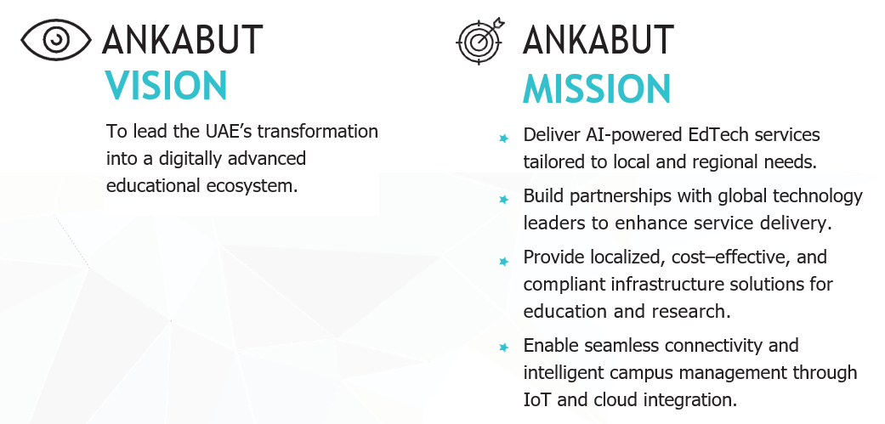

✔ Experience in Higher Education
Ankabut has delivered solutions and services to dozens of UAE universities, research institutes, and academic partners, including Khalifa University, UAEU, Zayed University, and the Ministry of Education. We understand academic governance, institutional priorities, and digital maturity requirements.
✔ A National Company with Strategic Alignment
As a UAE government-affiliated organization, Ankabut is fully aligned with national initiatives for digital transformation, data sovereignty, and educational innovation. We ensure that our solutions meet both operational and regulatory expectations.
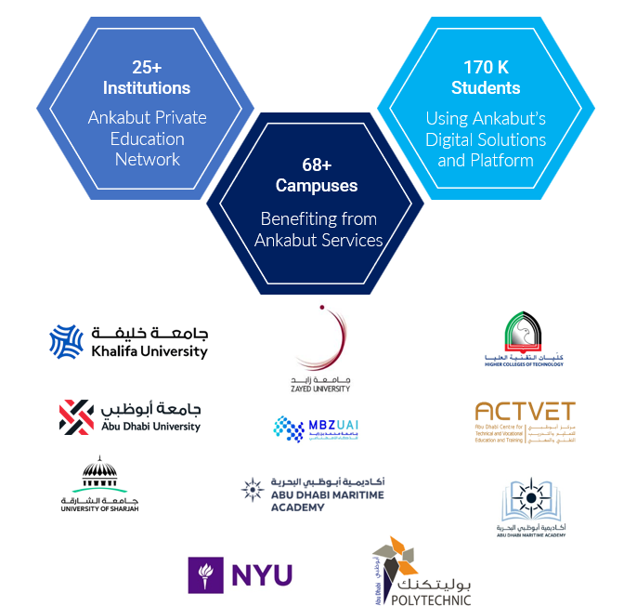

✔ Local Resources and In-Country Delivery
All services are delivered by Ankabut’s UAE-based team of engineers, architects, and project managers. We provide onsite deployment, local training, Arabic-speaking support, and full compliance with UAE data residency mandates.
✔ End-to-End EdTech Expertise
Ankabut delivers a complete portfolio of Digital Experience Platforms, including LMS, SIS, analytics, infrastructure, and cybersecurity — all integrated through a unified digital strategy tailored to education.
✔ Secure and Certified Infrastructure
Ankabut’s infrastructure is certified for ISO 27001, ISO 20000, ISO 22301, and Uptime Institute M&O standards. We manage a secure private cloud and local service management platform to ensure uptime, continuity, and risk mitigation.
✔ Service Commitment and Collaboration
KUEC will receive SLA-backed services, ongoing advisory support, access to the Reach ITSM platform, and a dedicated engagement manager. We act not only as a vendor but as a collaborative partner, facilitating KUEC’s vision of integration with KU, Sorbonne, and Rabdan.

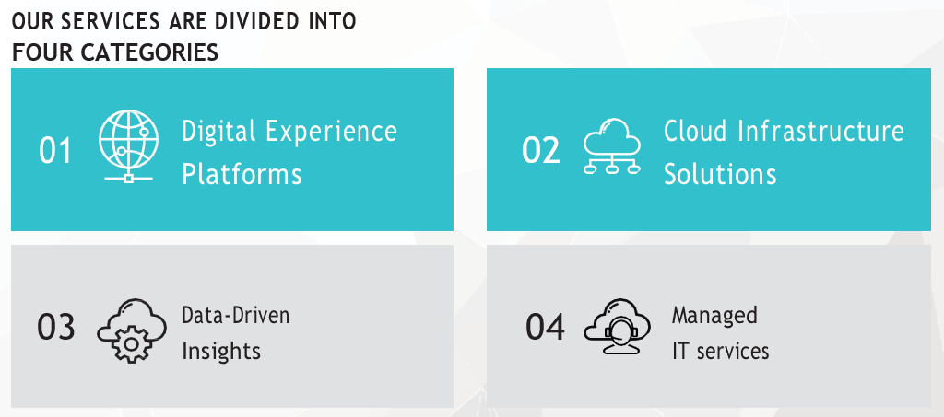

Conclusion
With Ankabut as the trusted solution provider, both proposed pathways offer KUEC a compliant, modern, and future-ready portal.
- The Creatio-based platform emphasizes configurability, scalability, and long-term digital transformation.
- The Odoo-based platform emphasizes speed to deployment, cost efficiency, and ERP-driven integration.
Either option will enable KUEC to deliver a next-generation service portal that enhances operational excellence, improves partner engagement, and supports the CoE’s ambition to become a national and regional hub for innovation and enterprise services.

Solution Description (The Two Options)

Option1 - Creatio-based Digital Platform

Creatio Overview
Creatio is a global vendor of one platform to automate industry workflows and CRM with no-code and maximum degree of freedom. Millions of workflows are launched on our platform daily in 100 countries by thousands of clients. Genuine care for our clients and partners is a defining part of Creatio DNA.
Creatio offerings include a no-code platform (Studio Creatio), CRM applications (marketing, sales and service), industry workflows for 20 verticals and marketplace add-ons. We help our customers digitize workflows, enhance customer and employee experience, and boost the efficiency of commercial and operational teams. Creatio is recognized as a Leader and Strong Performer in multiple Gartner and Forrester reports. Creatio products receive raving end-user reviews on peer-to-peer portals.
Our customers enjoy the freedom to own their automation. Freedom is provided through unlimited customization, the ability to build apps without a line of code and a universe of ready-to-use templates and connectors. Our platform empowers knowledge workers to build applications with no-code while increasing organizational capacity.
We believe in genuine care. We build sincere relationships with our clients and partners by giving a hand first and then thinking about business, communicating transparently and openly, and listening, adjusting and bringing value.
Creatio is headquartered in Boston, MA. We have over 700 employees in six offices and a local presence throughout 25 countries. Creatio has long-lasting relationships with some of the world’s most successful organizations including AMD, Bayer, Kraft Heinz, Visteon, Société Générale Group, BNP Paribas Group and many others. Creatio partners with 750 GSIs and local integrators.
Our culture is about genuine care for our clients and partners, passion, going the extra mile and staying positive.

Leadership and achievements
FORRESTER
 | 
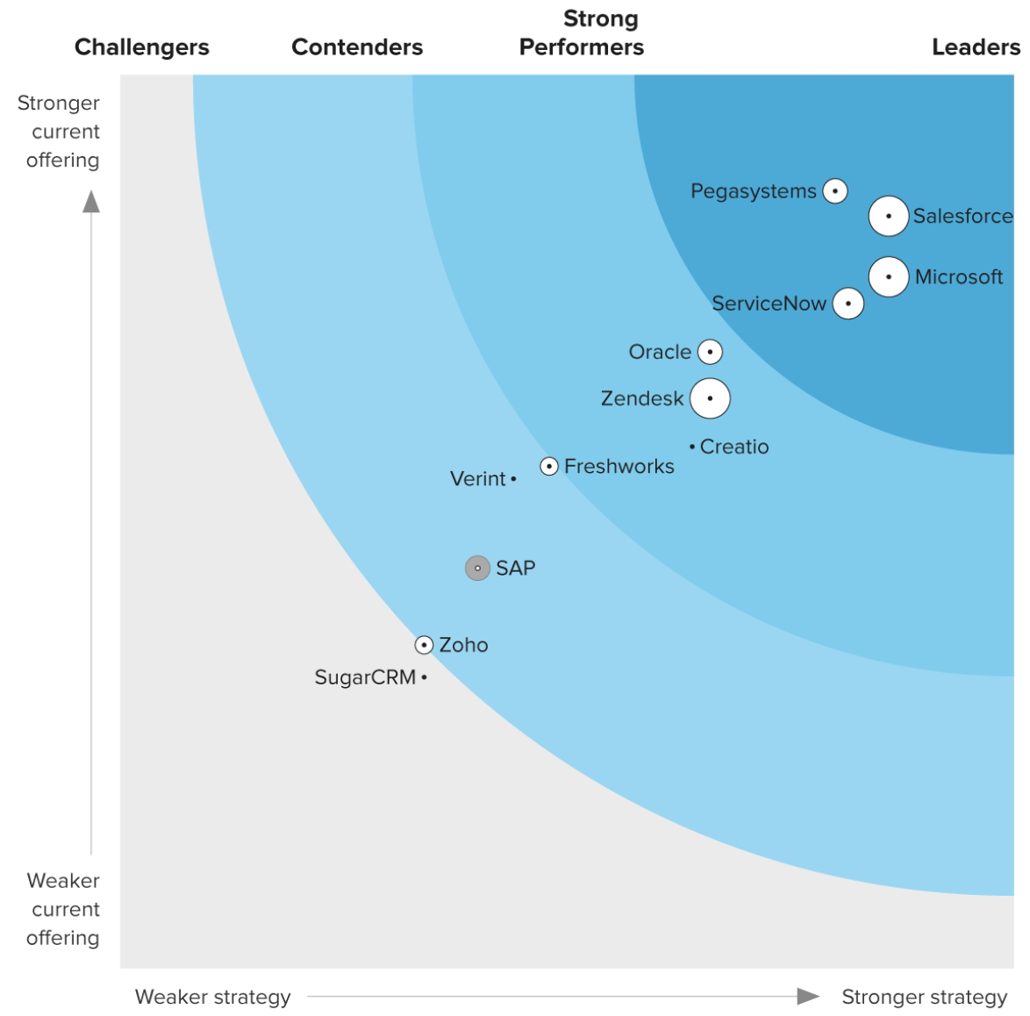 | 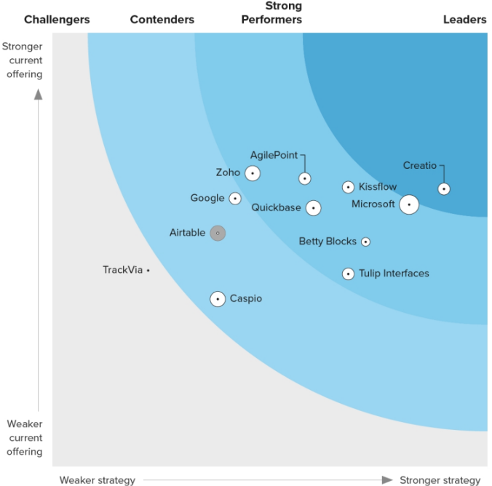
A Strong Performer in The Forrester Wave™: Customer Service Solutions, Q1 2024 | Creatio named as Leader in The Forrester Wave™: Low-Code Platforms for Citizen Developers, Q1 2024
 | 
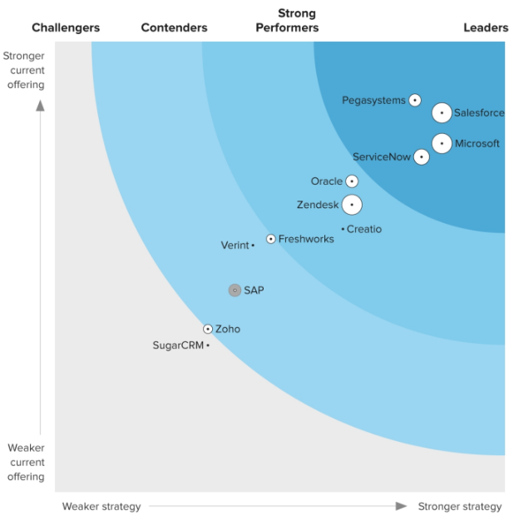 | 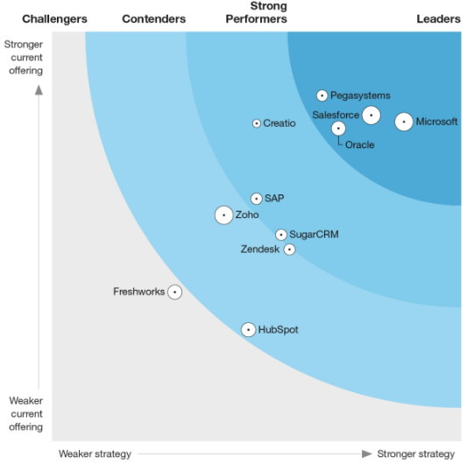
Creatio named a Strong Performer in The Forrester Wave™: Customer Service Solutions, Q1 2024 | Creatio named a Strong Performer in The Forrester Wave™: Core CRM Solutions, Q3 2022
 | 
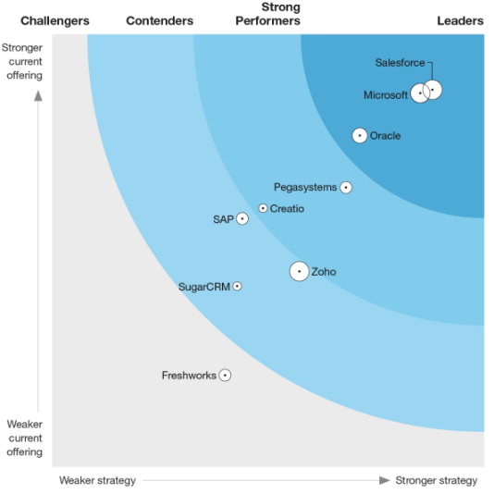 | 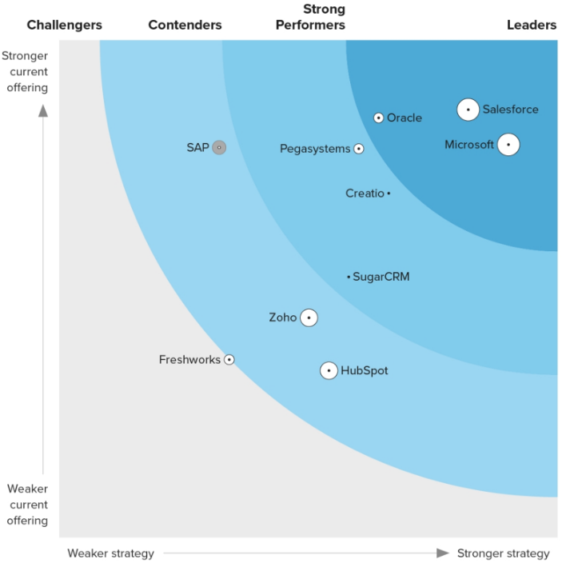
Creatio named as Strong Performer in The Forrester Wave™: CRM Suites, Q3 2022 | Creatio named as Strong Performer in The Forrester Wave™: Sales Force Automation Solutions, Q3 2023

GARTNER
  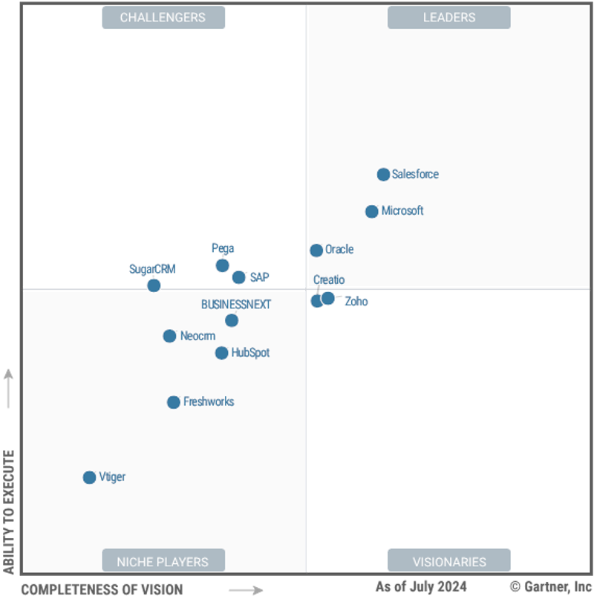 |   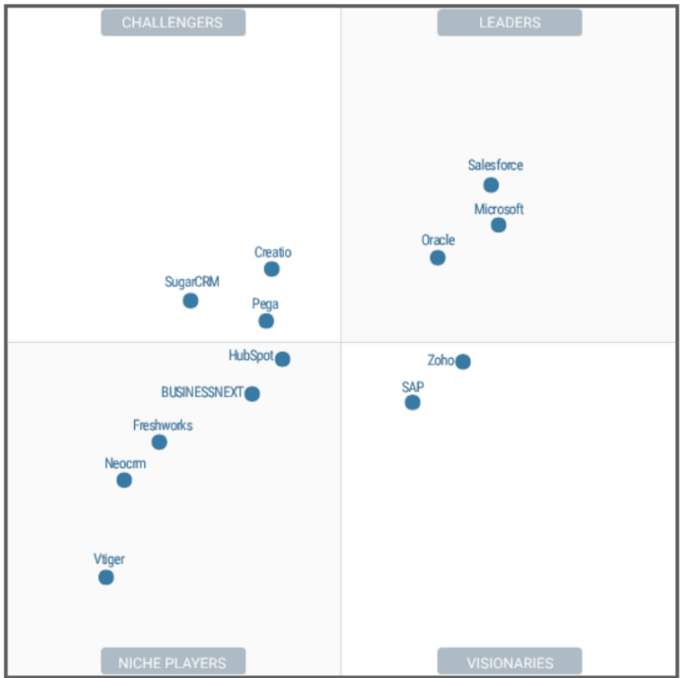 | 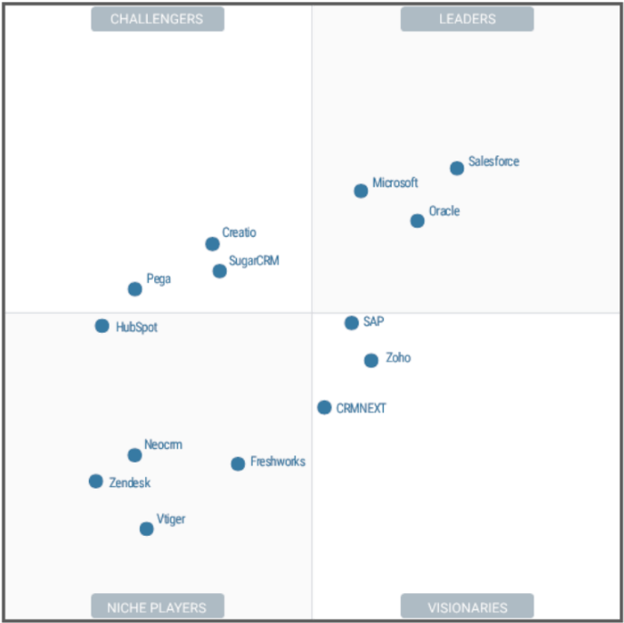
Creatio named as Visionary in the Gartner Magic Quadrant for Sales Force Automation, 2024 | Creatio named as Challenger in the Gartner Magic Quadrant for Sales Force Automation, 2023 | Creatio named as Challenger in the Gartner Magic Quadrant for Sales Force Automation, 2022
  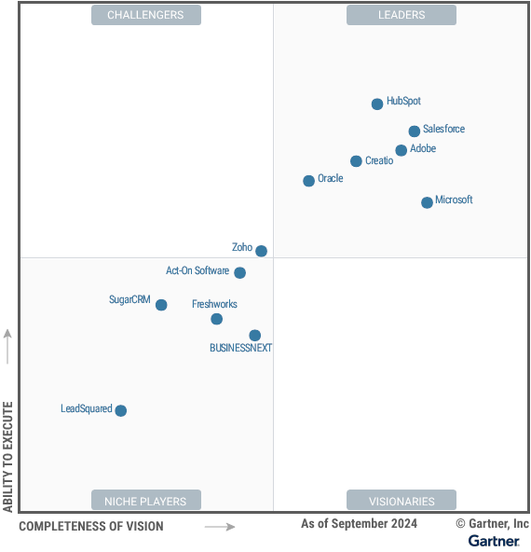 | 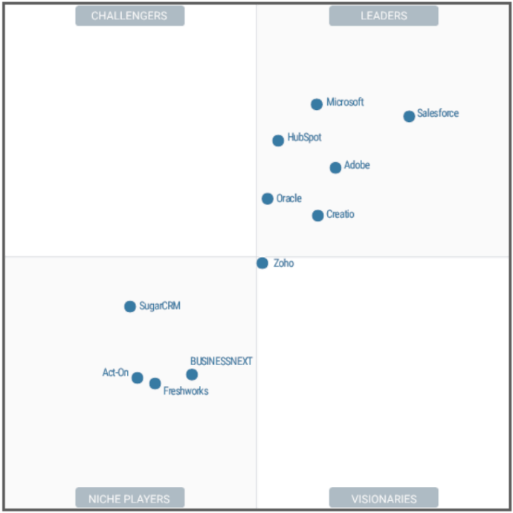 | 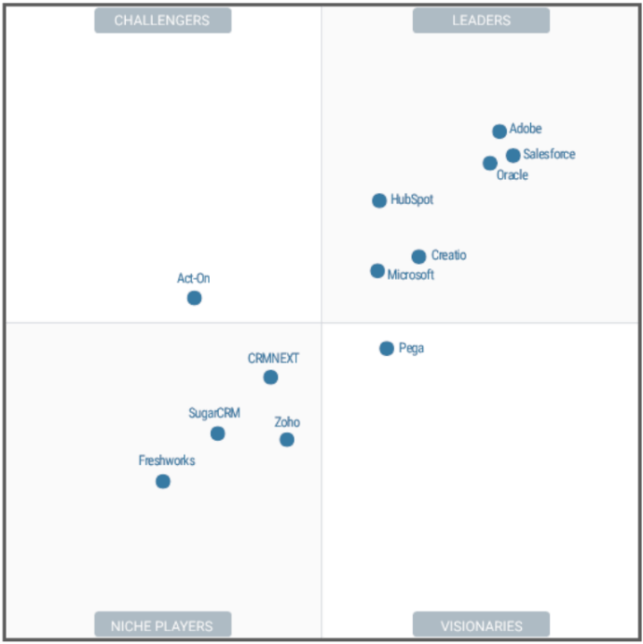
Creatio named as Leader in the Gartner Magic Quadrant for B2B Marketing Automation Platforms, 2024 | Creatio named as Leader in the Gartner Magic Quadrant for B2B Marketing Automation Platforms, 2023 | Creatio named as Leader in the Gartner Magic Quadrant for B2B Marketing Automation Platforms, 2022
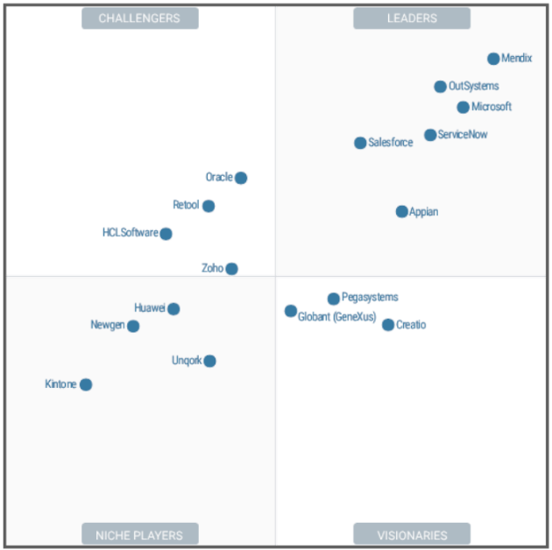 | 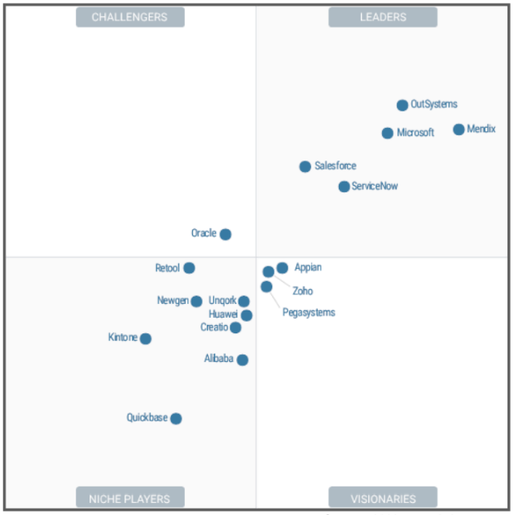 | 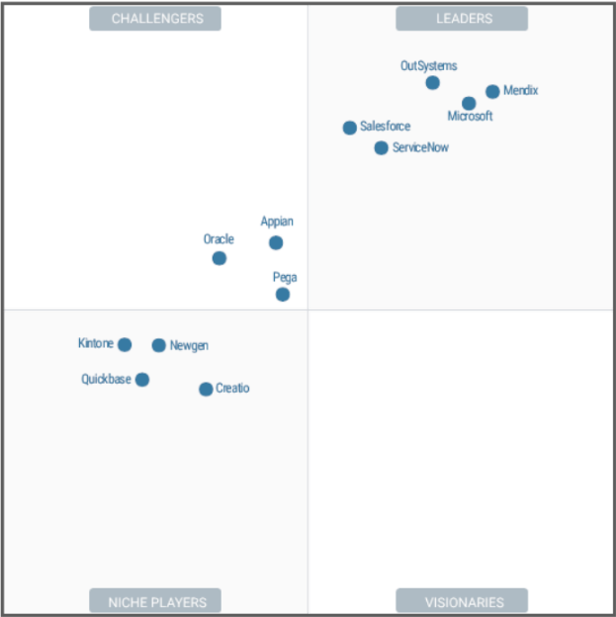
Creatio named as Visionary in the Gartner Magic Quadrant for Enterprise Low-Code Application Platforms, 2023 | Creatio named as Niche Player in the Gartner Magic Quadrant for Enterprise Low-Code Application Platforms, 2022 | Creatio named as Niche Player in the Gartner Magic Quadrant for Enterprise Low-Code Application Platforms, 2021

Global customer recognition
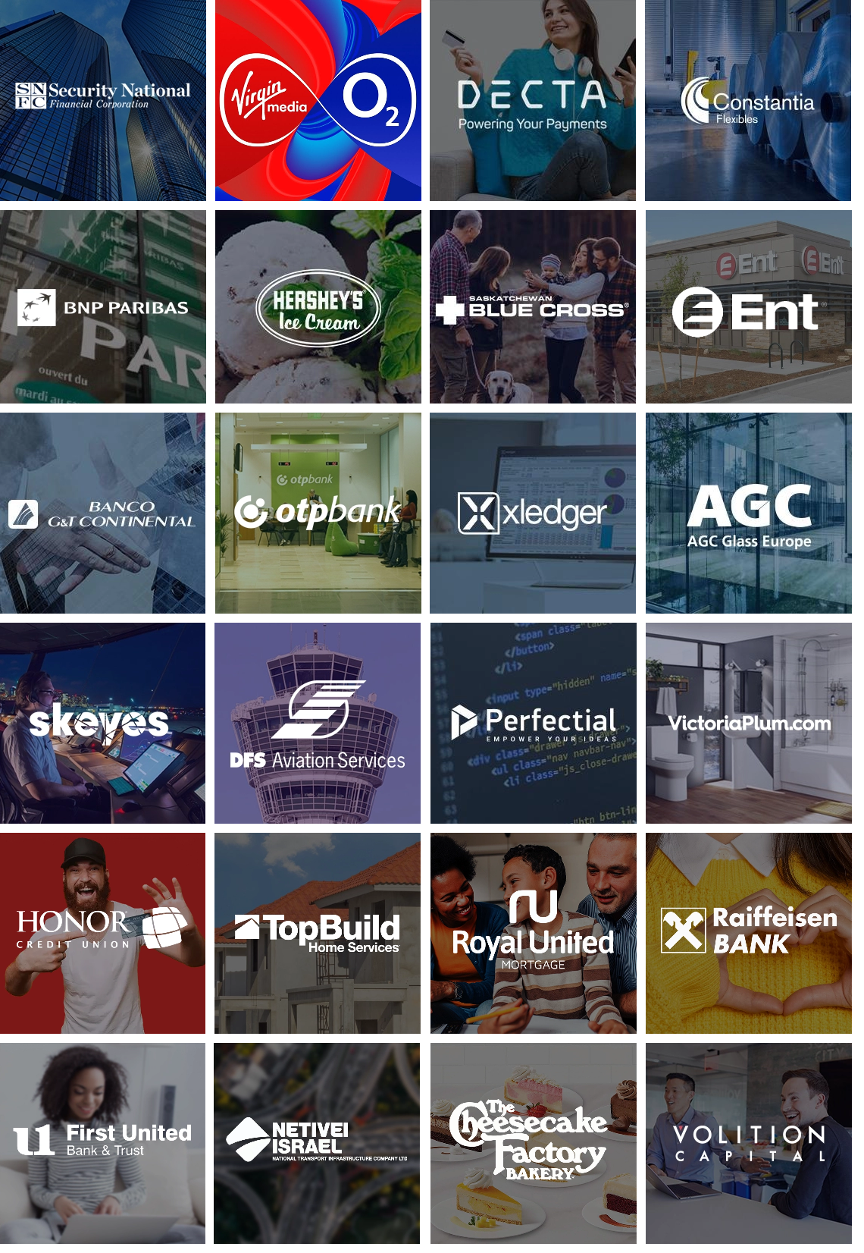
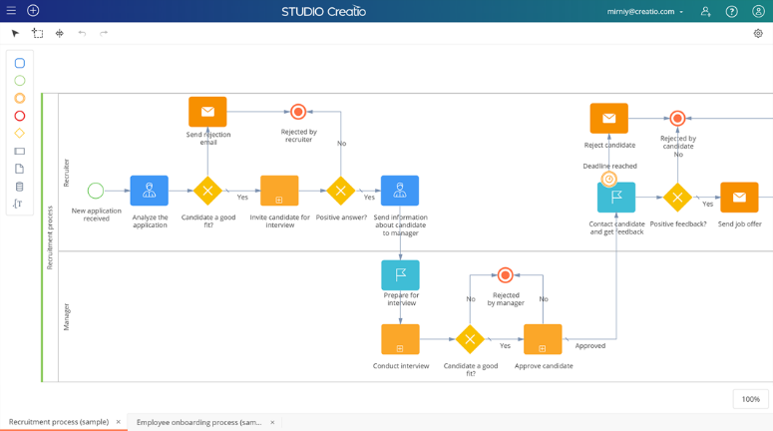
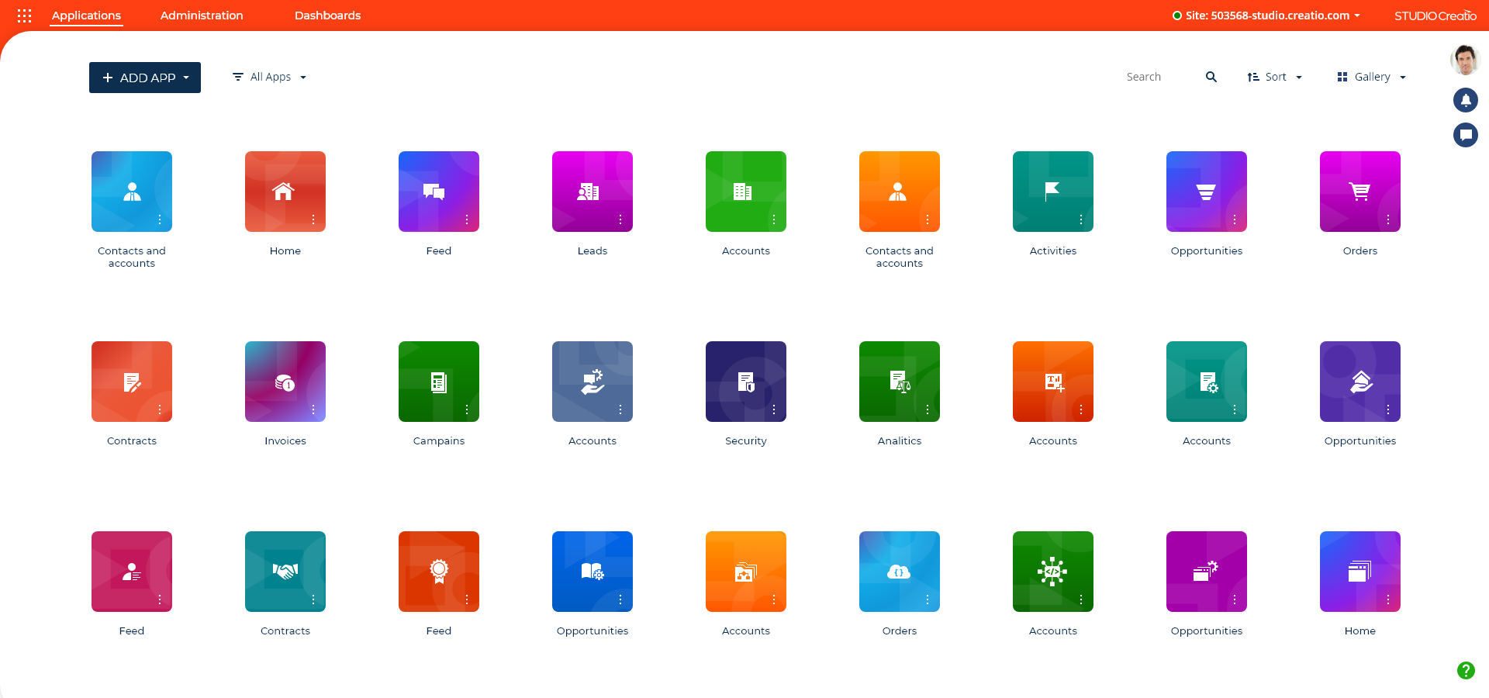

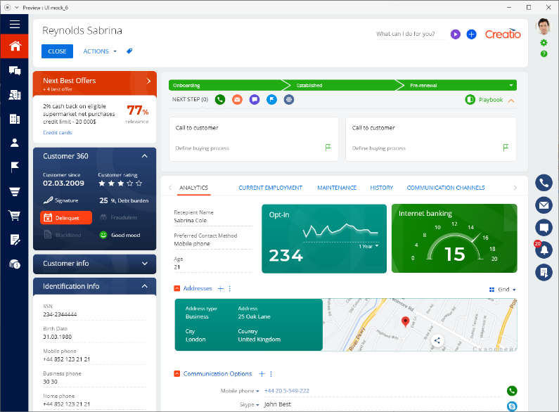
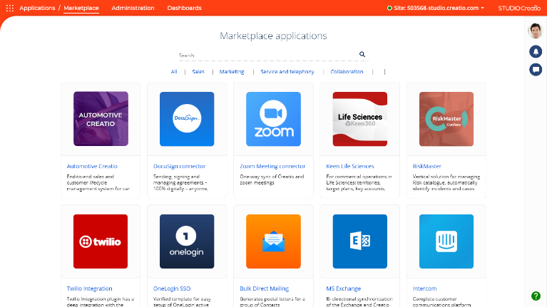
TO AUTOMATE WORKFLOWS AND CRM WITH NO-CODE AND A MAXIMUM DEGREE OF FREEDOM
TEMPLATES
and CONNECTORS
INDUSTRY WORKFLOWS
CRM
SERVICE
TEMPLATES
and CONNECTORS
SALES
ONE Platform
TEMPLATES
and CONNECTORS
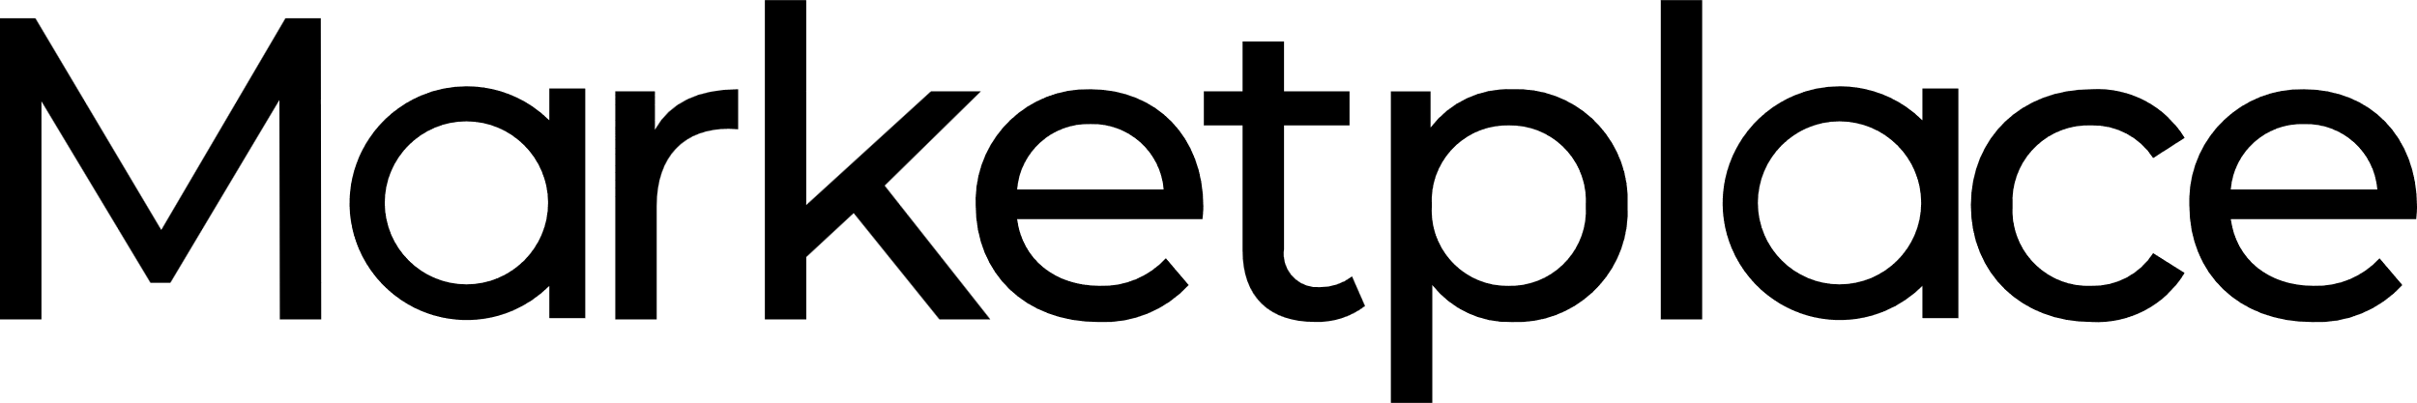
Mobile experience
Dashboards and analytics
No-code platform to automate workflows and build applications with a maximum degree of freedom

Creatio’s core product capabilities are extended via a growing marketplace ecosystem of pre-built applications

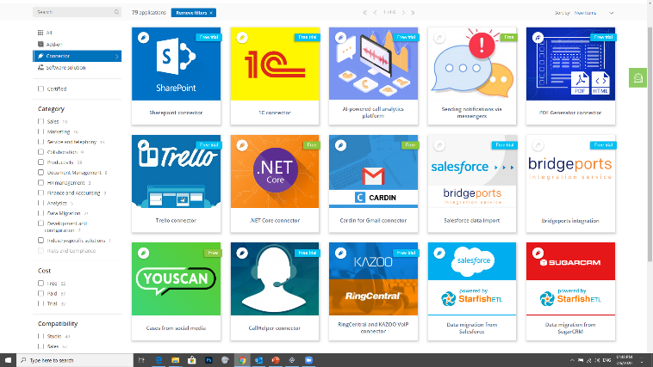
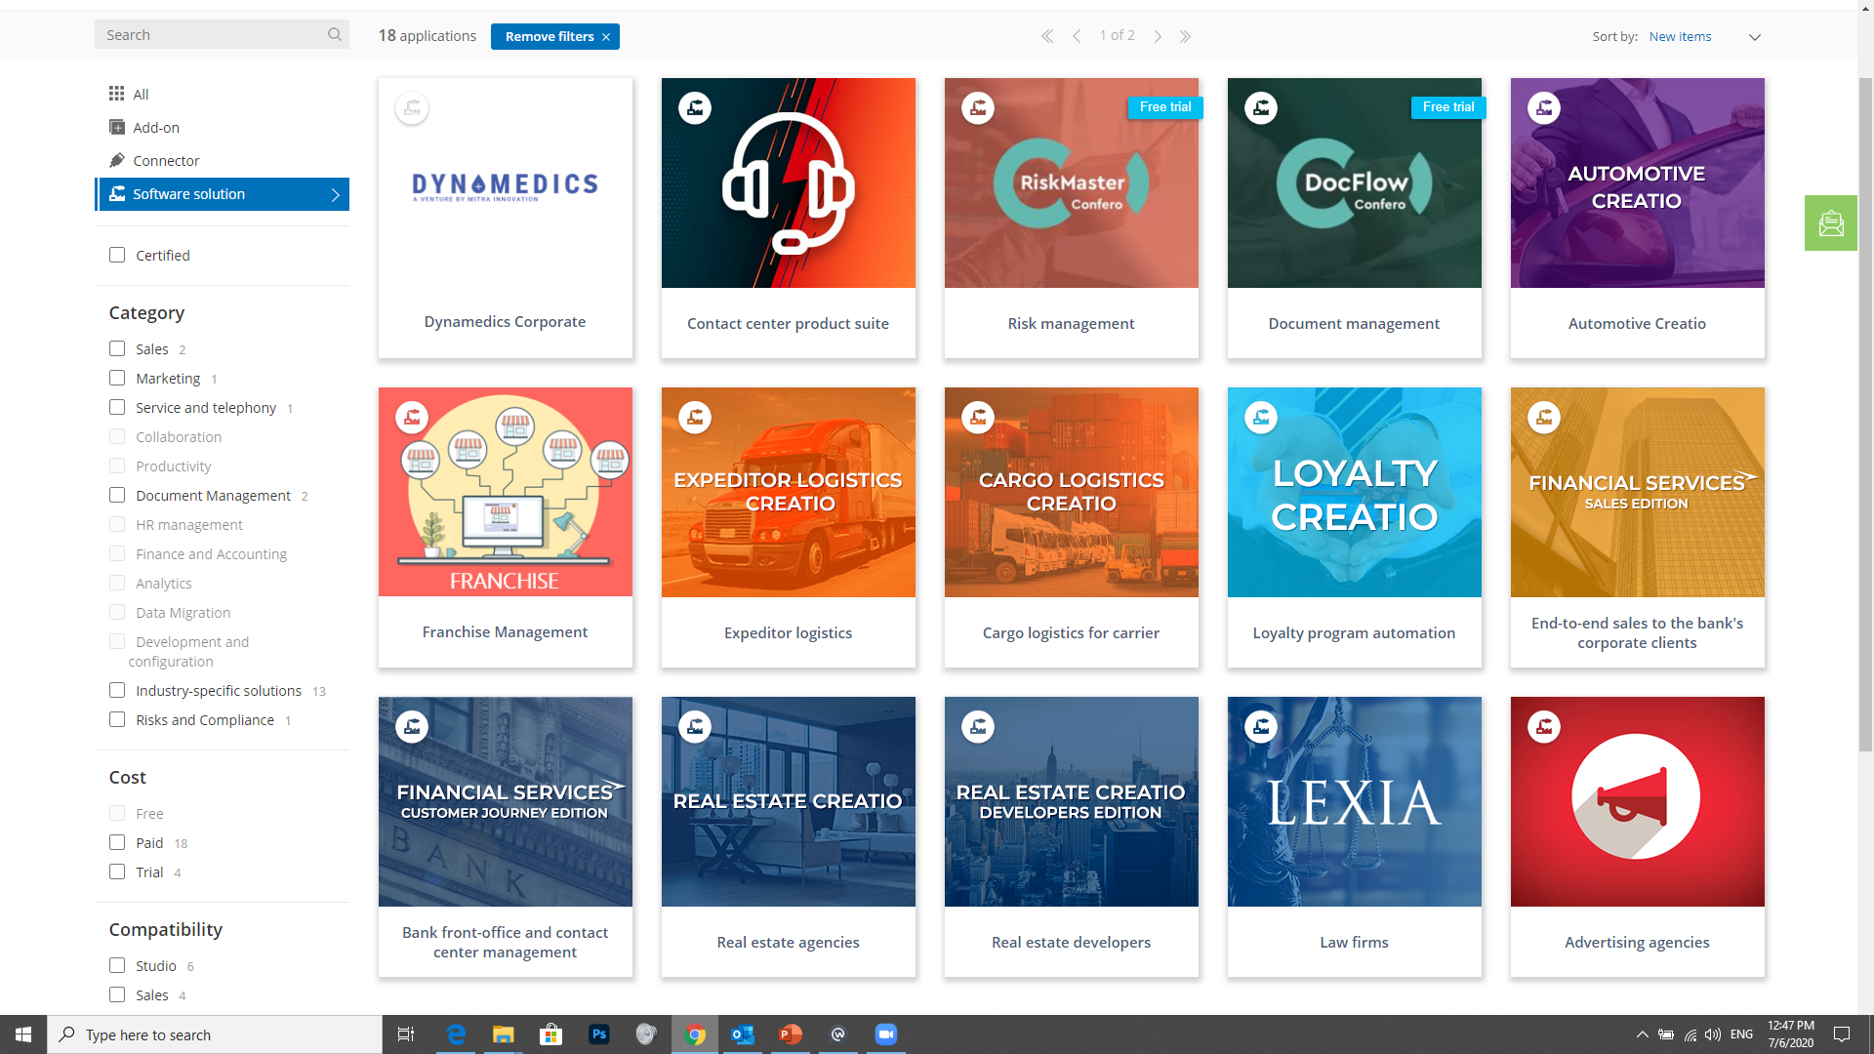
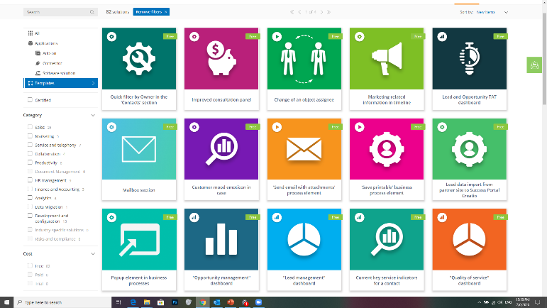
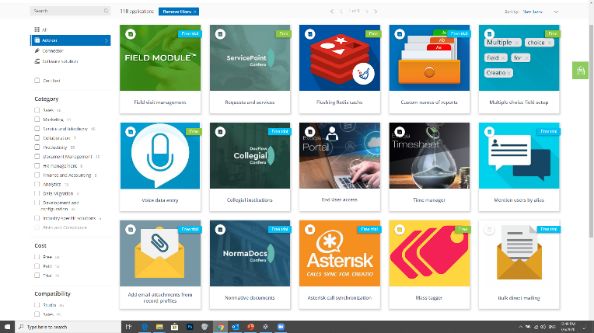
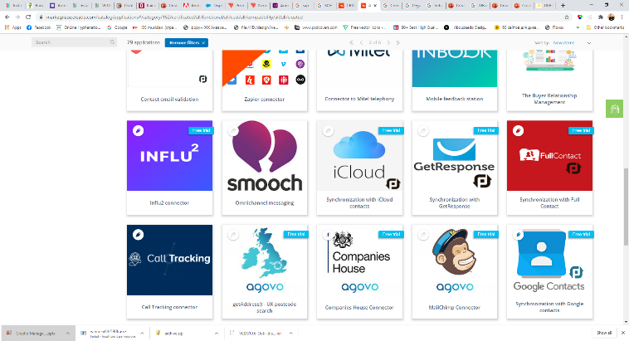
CONNECTORS
VERTICAL SOLUTIONS
TEMPLATES
ADD-ONS

Conceptual Architectural diagram
The conceptual architecture diagram presents the end-to-end structure of the KU CoE Services Platform, implemented using the Creatio low-code platform. It highlights the key interfaces, modules, and integrations that enable the delivery of 91 categorized services across governmental and non-governmental domains. The architecture ensures modularity, scalability, security, and alignment with KUEC’s operational requirements.

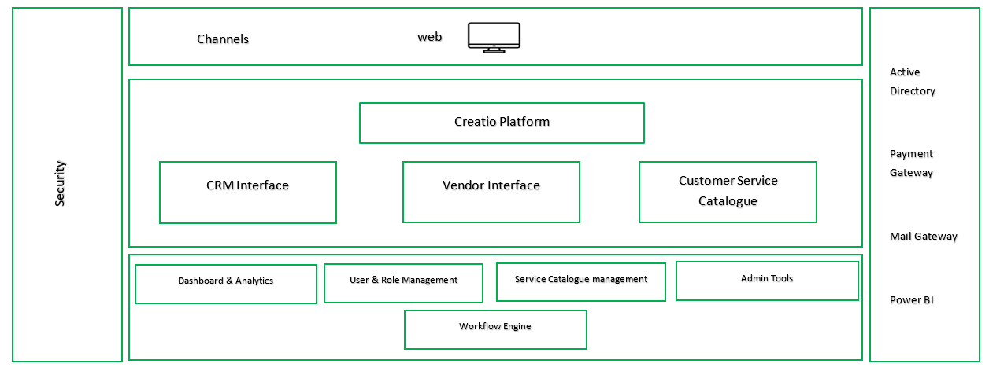

User Interfaces
The solution supports three role-based user interfaces, each tailored to a specific stakeholder group:
- CRM Interface: Used by CoE administrators and staff for managing service requests, internal approvals, and platform configuration.
- Vendor Interface: Enables service vendors to access, fulfill, and update assigned requests, including document upload and status handling.
- Customer Service Catalogue Interface: Provides startup customers with a streamlined view to request and track services from the full catalogue.

Workflow Engine
All services are executed through two standardized workflows — project-based and retainer-based — managed by the Workflow Engine at the foundation of the platform. This engine handles routing, SLA monitoring, approvals, and status transitions based on the configuration of each service.

Core Functional Modules
Positioned beneath the user interfaces, these modules enable system-wide logic and control:
- Dashboard & Analytics: Integrates with Power BI to deliver 22 operational and financial dashboards for internal use.
- User & Role Management: Manages access rights and user visibility across all roles and interfaces.
- Service Catalogue Management: Controls the metadata, document logic, pricing rules, and configurations for all 91 services.
- Admin Tools: Used by the CoE team to adjust offerings, define business rules, configure approval chains, and manage notifications.

Channels

The solution is accessed through a responsive web interface, ensuring compatibility across desktop and mobile browsers, without requiring native app development.

External Integrations

Creatio integrates with the following systems as part of the defined scope:
- Active Directory – For internal user authentication and Single Sign-On (SSO)
- Finance ERP – For service-related financial reconciliation
- Payment Gateway – Architecture allows future payment integration (not included in current phase)
- Mail Gateway – Supports delivery of 50 preconfigured email notification templates
- Power BI – Connected for real-time reporting and analytics
- Phone Logs – Integration-ready to attach call history to support requests
- Chat Tool – Enables logging of customer conversations into service records

Security Layer
A platform-wide security layer enforces authentication, role-based authorization, data protection, and platform governance, ensuring compliance with KU University’s IT and privacy standards.

Scope Of Work

Scope Summary
The proposed solution will be delivered on the Creatio no-code/low-code platform, enabling KUEC to digitize and manage its full-service portfolio across three dedicated user interfaces:
- A Customer Portal for startups to request and track services.
- A Vendor Portal for third-party service providers to fulfill assigned tasks.
- An Admin Interface for CoE teams to manage operations, approvals, and performance.

The platform will support over 91 services, structured under:
- Project-Based Services.
- Retainer-Based Services.
While only two standardized workflows will be used to deliver services (project-based and retainer-based), the platform will dynamically configure each service based on the rules and categories outlined in the service catalogue and RFI including required documents, SLA timelines, approval paths, and delivery conditions.

Phase 1: Assessment and Requirement Gathering
In this foundational phase, ANKABUT will conduct a comprehensive assessment of the KUEC’s existing systems, workflows, and services to ensure that the proposed Creatio solution aligns seamlessly with their operational needs and strategic objectives.

The primary focus is to gather detailed insights from key stakeholders, identify automation opportunities, and define a clear roadmap for a scalable, integrated platform that will enhance KUEC’s digital service delivery.

Study of Existing Systems
ANKABUT will conduct an in-depth review of existing Architecture, system integrations, and user interfaces. The goal is to identify strengths and weaknesses, potential pain points, and Opportunities to consolidate, automate, and enhance existing processes in line with KUEC’s digital transformation strategy. The analysis will ensure that the new Creatio solution builds on KUEC’s current strengths while addressing any functional or technical limitations identified, including the integration with existing systems.

Key deliverables:
- Detailed documentation of the current system architecture.
- A comprehensive analysis of limitations or pain points in the existing system.
- A high-level system landscape diagram highlighting key components.

Requirement Gathering
ANKABUT will engage with key stakeholders from KUEC to fully understand their business requirements, operational challenges, and future goals. This process will involve conducting interviews, workshops, and process reviews across departments. Each department’s requirements will be mapped to the proposed solution to ensure it covers essential needs, such Process mapping of the 91 services listed in the RFI, integration points, and data exchange requirements. Also, Mapping requirements to Creatio capabilities, ensuring coverage for form design, workflow automation, notifications, and integration.

Key deliverables:
- A detailed requirement specifications document.
- A list of critical success factors for the project.
- Identification of dependencies, risks, and challenges.

System Recommendation
Following the assessment and requirement gathering, ANKABUT will propose a comprehensive system design tailored to MOEC’s needs. The design will recommend the appropriate processes, services, and technologies to achieve optimal functionality. ANKABUT will provide best-practice recommendations for system design, including a detailed implementation roadmap, integration points, and technologies using Creatio

Key deliverables:
- A proposal for a future-proof system design leveraging Creatio Native Capabilities.
- Recommendations for digitizing and automating key processes and workflows.
- A solution architecture outlining the required components and integrations while adhering to Business continuity.

Phase 2: Implementation scope
The proposed solution will be delivered on the Creatio no-code/low-code platform in a modular architecture with the modules mentioned as follows:

Registration & Access Management
This module governs the onboarding and access control processes for all platform users, ensuring secure and structured entry into the system. It facilitates the registration and approval of both startup customers and service vendors, through workflows that manage identity verification, document upload, administrative review, and final approval or rejection. The system also handles disqualification and cancellation scenarios for suspended or ineligible users, along with automated notifications to guide applicants and alert internal teams throughout the process.

Functional Components:
- Startup Registration and Approval
- Vendor Registration and Approval
- Disqualification and Cancellation Handling

Users Involved:
- Startup Applicants
- Vendor Representatives
- Internal CoE Admins

Customer & Vendor Profiling
This module provides a structured approach to classifying and profiling platform users after successful registration. It enables the CoE team to define, manage, and update segmentation criteria for both startups and vendors, ensuring that service delivery logic—such as routing, pricing, and priority handling—can be dynamically adapted based on profile attributes. Segmentation helps users align with relevant services, workflows, and reporting dimensions.

Functional Components:
- Customer Segmentation
- Vendor Classification

Key Deliverables:
- Profiling dashboards for startups and vendors
- Segmentation rule configuration
- Dynamic tags or categories (e.g., size, sector, maturity level)
- Integration with service logic (e.g., smart routing, pricing tiers)

Users Involved:
- Internal CoE Admins

Product & Service Management
This module governs how services are structured, presented, and dynamically routed within the platform. It manages the core logic behind the digital service catalogue, including how services are displayed to users, how routing decisions are made (e.g. assigning vendors), and how configuration elements such as pricing, required documents, and eligibility are handled per service. This module is foundational to enabling the platform’s flexibility, supporting future service additions without the need for technical redevelopment.

Functional Components:
- Service Catalogue Browsing
- Service Offering Matrix
- Smart Routing Engine
- Onboarding Package Checklist
- Dynamic Pricing Logic
- Document Management Setup (for service-related files)

Key Deliverables:
- Public-facing catalogue interface for customers
- Admin configuration dashboard for service definitions
- Rules engine for vendor assignment and routing
- Logic for mandatory/optional document definitions per service
- Onboarding package pre-configuration (22 services bundled)
- Conditional pricing framework per service category or profile

Users Involved:
- Startup Customers (service browsing and request)
- Internal CoE Admins (catalogue and rules setup)
- Vendors (receiving routed requests)

Service Fulfilment
This module manages the core execution of all services requested through the platform. It is responsible for initiating, tracking, and closing service delivery workflows across both project-based and retainer-based categories. Rather than building isolated workflows for each service, the system will leverage two reusable fulfillment templates (project or retainer), with conditional branching based on service type, complexity, and vendor involvement. It also handles service-specific communication, vendor assignment, progress tracking, and refund logic where applicable. This ensures operational consistency while allowing flexibility in how different services are managed.

Functional Components:
- Project-Based Services Workflow
- Retainer Services Workflow
- Service/Vendor Assignment
- Service Request–Related Communication
- Detailed Service Card Deployment
- Customer Confirmation & Completion
- Service Cancellation & Refund
- Wallet or Card Refund Logic

Key Deliverables:
- workflows for project and retainer delivery
- Service metadata logic for branching
- Communication channels tied to each service case
- Dynamic vendor matching logic (manual or rules-based)
- Completion confirmation flow for customer and admin
- Refund handling logic

Users Involved:
- Startup Customers
- Vendors / Service Providers
- CoE Admins and Reviewers

Support & Communication
This module enables real-time and asynchronous communication between customers, vendors, and the CoE team throughout the service lifecycle. It provides tools for managing internal ticketing, logging external communication events, and reassigning or merging service requests when needed. The module ensures that all service-related interactions are captured, traceable, and tied to specific service requests. To support live engagement and ongoing collaboration, phone logs and customer-facing chat will be integrated with Creatio using its open API and available marketplace add-ons.

Functional Components:
- Integrated Chat and Phone Logs
- Offline Support Requests / Ticketing
- SR Reassignment and Tracking
- Automatic SR Creation and Merge

Key Deliverables:
- Support dashboard for internal CoE users
- Ticket creation interface for customers
- Chat Integration
- Phone log tracking integrated with service cases
- Reassignment workflows and merge logic for duplicating SRs
- Escalation workflows for complex issues

Users Involved:
- External & Internal Customers
- CoE Admins and Support Agents

Data Reporting & Analytics
This module provides centralized access to operational and financial insights through a set of predefined dashboards and reports. A total of 22 dashboards and reports will be implemented, covering all core modules and service categories across the platform. Reporting will be powered by Power BI and integrated with Creatio’s platform, enabling the CoE team to visualize key metrics, monitor SLA performance, track customer feedback, and analyze financial indicators such as revenue and cost distribution. Reports will be configured based on role permissions and will reflect real-time data pulled from Creatio’s internal database.

Functional Components:
- Financial Reports
- Operational Reports
- Generic Dashboards and Reports

Key Deliverables:
- 22 role-based dashboards and reports across all modules
- Power BI integration with Creatio’s data layer
- Visual insights into service fulfillment performance and user activity
- Exportable report views and filters
- Report on access configuration based on admin roles

Users Involved:
- CoE Admins
- Management and Oversight Teams

Platform Administration & Shared Modules
This module encompasses the administrative and configuration tools needed to support day-to-day platform governance and operational agility. The Admin Tool, accessible via the CRM interface, will empower authorized CoE users to:
- Adjust and update product and service listings with respective service coding definition, including pricing and descriptions
- Reconfigure service packages or bundled offerings based on evolving onboarding or engagement models
- Modify core business logic governing service routing, document requirements, and approval layers
- Manage user assignments, service statuses, and operational flows from a centralized interface

The platform will also include a configurable document handling layer, built using Creatio’s native capabilities. This includes defining which services require document uploads, setting mandatory vs. optional fields, attaching files to service records, and enabling document download visibility per user role — all without requiring custom development.

Notifications will be managed via Creatio’s template engine and business process designer. A total of 50 email notification templates will be implemented, each mapped to key events such as registration approvals, service updates, assignment alerts, and feedback confirmations.

Functional Components:
- Admin Tool for Product/Package Management
- Business Logic Configuration Panel
- Role and Access Management
- Document Upload Rules and Visibility Settings
- 90 PDF Generation Templates for Service Records
- Notification Engine with 50 Email Templates

Key Deliverables:
- Configurable admin views for platform control
- Tools for adjusting service packages, pricing, and routing logic
- Document upload rules embedded in service request forms
- Centralized control over notification content and delivery logic
- Role-based access control for users across all interfaces

Users Involved:
- CoE Admins
- Platform Supervisors

Service Catalogue
Each of the 91 services will be developed according to its complexity category according to our complexity Matrix as follows :
Description / Criteria | Complex | Medium | Easy
Users Involved | 8-10 | 6-8 | 2-4
No. of actions | 8-14 | 6-11 | 2-6
No. of Pages | 7-10 | 5-8 | 2-5
No. of Fields | 30-40 | 20-30 | 5-10

Our Estimated Services Complexity mapping:
Complex | Medium | Easy
17 | 27 | 47

Governmental Services
This module enables the delivery and tracking of government-related services offered to customers. It covers a wide range of formal procedures including company setup, visa processing, health insurance subscriptions, and official documentation. Each service is made available through the customer interface with configurable request forms, required document handling, and status tracking. All services will be routed through either the project-based or retainer-based workflow engine, depending on their classification. Service-specific configurations such as required inputs, approvals, and delivery format will be defined using metadata aligned with the service catalogue and RFI.

The module includes a total of 26 government services, categorized as follows:
- Establishment and Licensing Services – 12 services
- Visa and Health Insurance Services –10 services
- PRO and Government Liaison Services – 4 services

Functional Categories:
- Establishment and Licensing Services
- Visa and Health Insurance Services
- PRO and Government Liaison Services

Key Deliverables:
- Service request forms tailored per government service
- Status tracking and submission flows per service
- Validation and document attachment logic based on configuration
- Role-based visibility per service step (e.g., customer, CoE, vendor)

Users Involved:
- Startup Customers
- CoE Admins
- Vendors (where applicable)
=

Non-Governmental Services
This module covers all non-governmental services offered to startups through the platform, supporting their business growth across key operational domains such as marketing, finance, HR, IT, procurement, and legal. These services are delivered through either the project-based or retainer-based workflow templates, depending on the nature of the request. Each service will have its own metadata configuration—allowing dynamic setup of required fields, document uploads, pricing rules, and routing logic. Customers will be able to submit requests, track status, and interact with assigned vendors or the CoE team based on role-based access permissions.
The module includes a total of 62 non-governmental services, categorized as follows:
- Marketing & PR – 11 services
- Finance – 12 services
- Procurement – 5 services
- Human Resources – 17 services
- IT & Technology – 10 services
- Facility Management & General Business Services – 8 services
- Legal Services – 2 services

Functional Categories:
- Marketing & PR
- Finance
- Procurement
- Human Resources
- IT & Technology
- Facility Management & General Business Services
- Legal Services

Key Deliverables:
- Configurable service request forms with metadata per service
- Routing logic for vendor assignment and internal workflows
- Document upload fields tied to service request types
- Retainer/project-based delivery setup per category
- Customer tracking interface for service status
- Vendor access to task details and document uploads (where applicable)

Users Involved:
- Startup Customers
- CoE Admins
- Vendors (as assigned per service)

Phase 3: Pre-Go-Live Support
This phase focuses on preparing the system for deployment and ensuring a smooth transition to the new Creatio platform.

Training and Documentation
ANKABUT will conduct comprehensive training for KUEC’s staff, ensuring they are proficient in using the new system. This will include technical and functional training, as well as providing detailed user manuals and system documentation.

Key deliverables:
- Training sessions for system users.
- User manuals and system documentation.
- Support materials for post-Go-Live use.

Go-Live Preparation
In the final stage of this phase, MOEC will conduct final testing, load balancing, and security assessments to ensure the system is ready for Go-Live. MOEC will be available to provide immediate support during this critical period.

Key deliverables:
- Final system testing, including performance and security assessments.
- Ready-to-go system for the official Go-Live.

Phase 4: Post-Go-Live Support
After the system is live, ANKABUT will provide ongoing support to ensure stability, address any issues, and make necessary adjustments based on real-world usage.

Hyper care and Maintenance support
ANKABUT will provide onsite support for a Four weeks Hypercare period divided into Two weeks period after the end of each implementation phase (consists of 3 sprints). During this time, any bugs or issues that arise will be addressed immediately, and the system will be fine-tuned to optimize performance. Maintenance and.

Key deliverables:
- a Four weeks Hypercare period divided into Two weeks period after the end of each implementation phase
- Issue resolution and system stabilization.
- Continuous performance monitoring and tuning.

Change Management
ANKABUT will address any required changes based on KUEC’s evolving needs, ensuring the system continues to function optimally. This includes making updates and implementing change requests.

Key deliverables:
- Handling and implementing change requests.
- System updates based on performance or new requirements.

Ongoing Maintenance
ANKABUT will provide ongoing maintenance services, including regular updates, security patches, and backup monitoring to ensure data safety and system reliability.

Key deliverables:
- Scheduled system updates and security patches.
- Regular backup and recovery checks.

Integration Scope
The Creatio-based platform will integrate with the following external systems to ensure smooth operational flow, data synchronization, and user experience continuity with total 11` integration point . All integrations will be implemented using Creatio’s native integration tools, connectors, or open API framework, depending on the capabilities of the external system.
- Mail Gateway for email notification purposes.
- Active Directory Single Sign-On (SSO) and user authentication for internal users.
- ERP to ensure smooth lifecycle with connection to the CRM interface.
- Payment Gateway to support real-time payment processing for services and refunds.
- Mail Gateway Delivery of automated email notifications based on service events.
- Power BI Advanced dashboarding and analytics over operational and financial performance.
- Phone Logs Capture and attach call records to service requests or support cases.
- Chat Tool Enable in-platform customer support chat and log messages to service cases.

Project – Option 1 Out Of Scope
The following items are explicitly excluded from the current scope of work and will not be delivered as part of this engagement. They may be considered for future phases based on KUEC's evolving needs and mutual agreement.

Custom Development Outside Creatio Platform
- Any functionality that requires custom backend coding or services outside the low-code/no-code framework of Creatio is excluded.
- All workflows, forms, logic, and integrations will be built using Creatio’s native capabilities and available connectors.

Government API Integration
- Direct integration with external government platforms (e.g. MOHRE, GDRFA, FTA) is not included in this phase. Services will be configured for manual handling with integration-ready design if future APIs become available.

Advanced Document Management System
- A full-featured DMS (with versioning, indexing, sharing, search, access rights, and archive logic) is not in scope. Document upload and attachment functionality will be implemented using Creatio’s standard capabilities only.

Mobile App Development
- Native or hybrid mobile applications are not part of this engagement. All services will be accessible via a responsive web interface.

BI Tool Licensing or Custom Analytics Platform
- The scope includes Power BI integration and configuration of 22 dashboards and reports; however, Power BI licensing, advanced modeling, or external BI systems are not included.

SLA-Based Automated Escalation Engines
- SLA tracking and basic reporting are in scope. However, fully automated escalation engines or AI-based prioritization logic are not included.

PDF and Notifications Templates
- PDF Generated template must not exceed 90 templates
- Notifications Mail Template must not exceed 50 Template.

Project - Option 1 Deliverables
Product Licenses for Low/No code platform | Major Deliverables
Licenses | Licenses Activation Certificate/Signoff
 | Product Manuals
 | Product download & Support portal Access
Professional Services for Low/No Code Platform/Product implementation | Major Deliverables
Mobilization | Mobilization of resources (Management approval, On boarding)  Approved Project Management Methodology & Project Management plan including all documents.  Detailed Project schedule
Installation | Installation & Configuration of the platform in Dev, Stagging & Prod. environments.  Solution Design Diagram  Deployment Design Diagram  Data dissemination diagram
Define Roles | Defining Roles & descriptions for maintaining tool within the organization
Business Training | Business Training on the developed application across enterprises with different business units (Train the trainer model). Provide training materials & user manuals
Technical Training | Technical training for IT teams  Instructor led online/hands-on training for developing applications on low code platform.  Detailed training agenda to be provided.  Provide training materials
Process | Change/enhancement management deployment for applications developed on Low/Code platform
Professional Services Scope of work | Major Deliverables
Requirement Gathering | Detailed Requirements document  Requirement traceability Matrix  Baseline schedule/Project Plan  As-is document  To-Be document
Solution Design (High Level & Low Level) | High Level Design document (HLD) for the To-Be  Low Level Design document (LLD) for the To-Be
Solution Implementation in Development Environment | Installation and Configuration Documents with screen shots from development environment  Source Code / other configuration files
Technical and Unit Testing | Test Case Document for Development Environment  Successful Test Run Documents  Technical / Integration Testing Sign-off  Development environment handover and admin password change  Updated Low Level Design document (LLD) (optional)
Software Implementation in Staging | Installation and Configuration Documents with screen shots from staging environment  Source Code / other configuration files  Test Case Document for Staging Environment  Technical / Integration Testing Sign-off  Successful Test Run Documents  Updated Low Level Design document (LLD) (optional)  Staging environment handover and admin password change
User Acceptance Testing & Training | UAT Sessions  UAT acceptance Sign-off from business  Technical Training Sessions  Business users Training.  Provide training materials & user manuals for both Technical & business users.
Go-Live | Production deployment runbook (cut over plan)  Go Live checklists & related documents preparation / submission.  Installation and Configuration Documents with screen shots from production environment  Source Code / other configuration files  Production Confirmation / Business Sign off
Professional Services– Post Implementation Support | Major Deliverables
Post Go-Live Support & issue resolution | End User Awareness Sessions  Issue resolution sign off.  Two weeks after phase one implementation and two weeks post go live support completion.  DR Testing Support  Backup and recovery guideline document  Production environment handover and admin password change
Project Closure | Lesson Learned documentation.  Updated / As-built Installation and configuration documents
Support & maintenance for Low/Code Platform | Major Deliverables
Support | Access to support portal.  Incident management

Project – Option1 Assumption
- ANKABUT will be proposing hybrid execution model wherein Project Manager, Business Analyst will be hybrid while development team is offshore, only the Team lead will be onsite.
- Support scope will be only supporting the scope of work implementation. No enhancements or tool support.
- Changes in scope defined in this proposal will be re-estimated and in case extra eﬀort are encountered then it will be treated as change request.
- ANKABUT will be carrying some of the implementation efforts at KUEC’s site (on-site) by the TL and some of the tasks will be accomplished at ANKABUT offices (off-site). This requires providing VPN access to the rest of the team.
- Secured VPN should be provided by KUEC to ANKABUT team to be able to complete the work and do the needed collaboration between ANKABUT on-site and off-site teams.
- This proposal covers the implementation of 91 services and three interfaces that adhere to the complexity matrix mentioned in the scope of work and any additional services will be quoted separately
- The proposal does not cover the procurement of any licenses which is not mentioned in the proposal or the implementation of any other 3rd party products.
- All project deliverables shall be made in one language Arabic or English.
- COVID-19 pandemic and its implications for performing work related to this project shall be treated as a FORCE MAJEURE.
- Resources mobilization period is 3-6 weeks.
- It is assumed that KUEC will conduct any Security/Penetration testing, if required. ANKABUT team will be responsible for fixing any issues identified because of the Security/Penetration testing
- There is no Data Migration included in the scope.
- All the APIs required for any external systems must be provided by KUEC.
- The detailed requirements, workflow details, and data elements to capture will be provided by the client.
- All the required hardware will be provided by the client.
- Type of approval and approval matrix will be provided by the Client.
- All the notification templates will be shared during the requirement-gathering phase.
- The client will provide all types of templates during the implementation of the application.
  - All integrations will be through standard integration gateways.
  - Integration with 3rd party systems will be limited to integration points defined in the above scope, any other integration received will be out of our scope, and subject to standard Change Management Process.
  - The total number of Integrations considered as part of this proposal is 11.
- The following is considered out of the scope of this proposal:
  - Any activities not mentioned in this proposal.
  - Any integration not mentioned in the scope of this proposal.
  - The procurement of any licenses other than mentioned in the proposal
  - Backup and restore mechanism and tools.
  - Any changes on 3rd party systems.
  - ANKABUT scope will be limited to provide the required static reports needed to be generated for the services using Power BI and embedded within Creatio implemented platform without direct integration.
  - Printing, publishing or distributing any project marketing material such as banners, brochures, newsletters, videos, and webpages.
- KUEC /ANKABUT Responsibilities Assumptions
  - KUEC will define and setup the steering committee members for the project from the ANKABUT within 1 month of project initiation.
  - KUEC shall assign the project manager and team members from KUEC that will be allocated to the project to perform pre-defined roles and responsibilities and do the needed reviews and approvals on project deliverables.
  - KUEC will be responsible for the coordination and ensuring the availability of the needed resources from all project stakeholders (at Agency or any other entity) to attend any needed workshop or meetings as per the project schedule, where any delays in this regard with its implication to the project progress will be KUEC responsibility.
  - KUEC shall make all needed resources from KUEC (business users, system admins …etc.) available during 1 week once requested by Agency for executing different project activities.
  - KUEC shall ensure the review and acceptance of project deliverables within 3 working days.
  - Agency shall facilitate the access to ANKABUT team to KUEC premises from 7:00 AM to 10:00 PM (when needed), and for additional time in some cases that requires full presence of ANKABUT team.
  - It is KUEC responsibility to build all needed integration points at their internal systems that requires integration with our proposed solution.

Project – Option 1 Team Structure

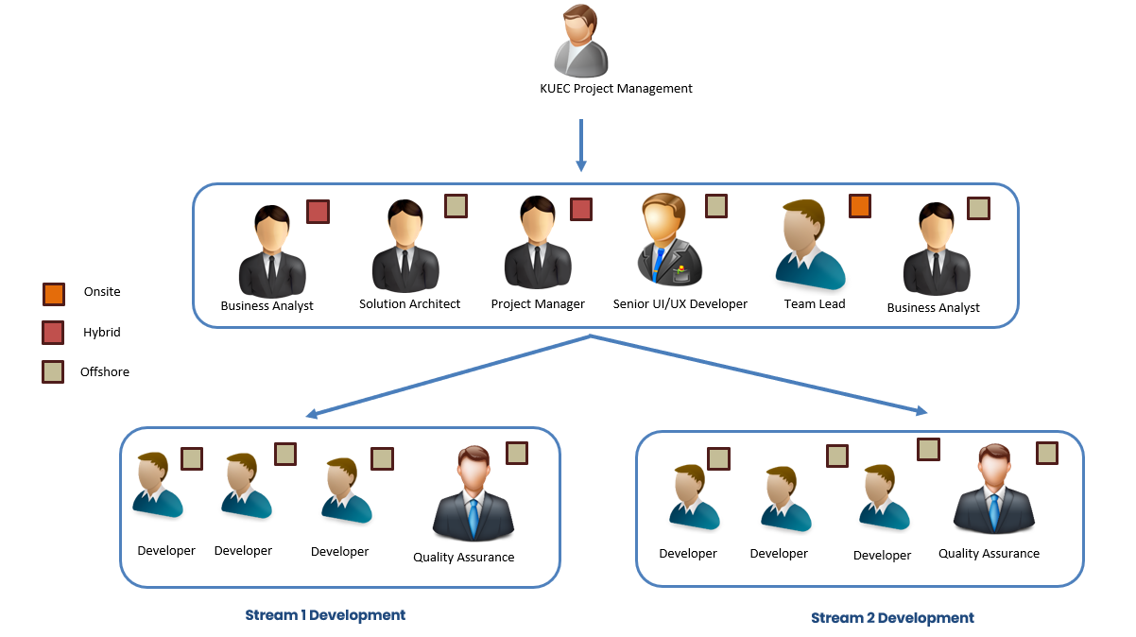
Team Structure

Roles & Responsibilities

Governance Layer
- Project Manager (Hybrid)
Oversees overall project delivery. Manages schedules, coordinates across teams, tracks progress, and ensures deliverables meet scope, quality, and timelines.
- Business Analyst (Hybrid)
Acts as the bridge between stakeholders and the delivery team. Gathers requirements, documents processes, and clarifies functional details.
- Business Analyst (Offshore)
Supports requirement gathering and documentation remotely. Works with the hybrid BA and technical team to ensure requirements are translated into clear specifications.
- Solution Architect (Offshore)
Designs the technical architecture, validates scalability and security, and ensures adherence to best practices.

Delivery Team
- Team Lead (Onsite)
Leads the development team, assigns tasks, monitors progress, and provides technical guidance.
- UI/UX Designer (Offshore)
Designs intuitive and user-friendly interfaces, ensuring consistency and seamless user experience.
- Creatio Developers (Offshore)
Develop and configure system features, implement customizations, fix bugs, and support integration efforts across the platform.
- QA Engineers (Offshore)
Conduct functional, regression, and UAT testing. Ensure solution quality, manage defect tracking, and validate workflows before go-live.

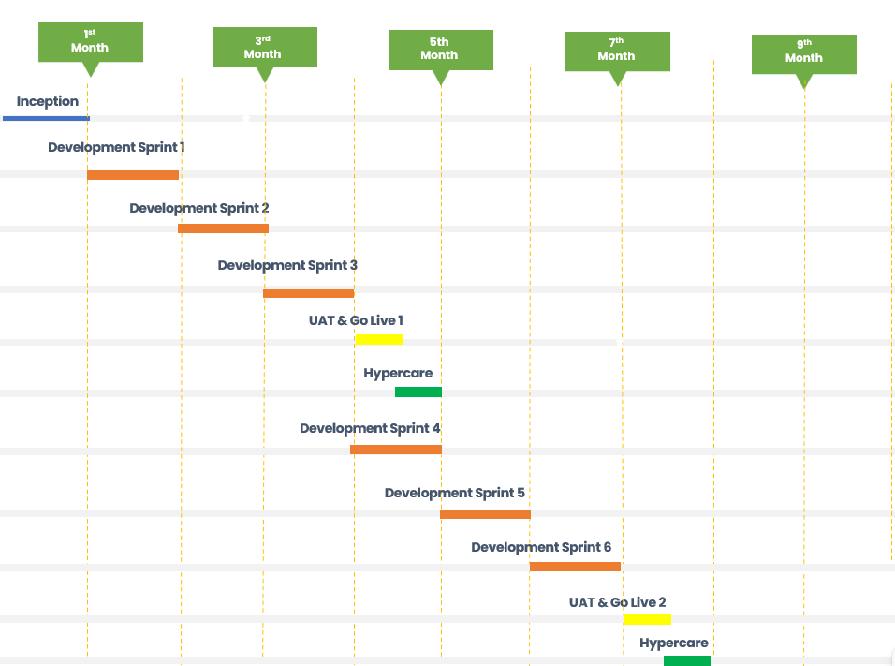
Project – Option1 Timeline

The project will be

executed by two Scrum teams and consists of the following phases:
- Inception Phase: 1 month
- Implementation (Development Sprints): 6 months separated into two phases each phase 3 sprints
- Go-Live and UAT: 1 month for both Scrum teams
- Hyper Care: 1 month for both Scrum teams

Project Team Structure
Since inception, ANKABUT has built up the most talented, skilled and experienced staff in the IT industry. This is evident through high employee retention rates, testimonies of our clients & the policy we exercise internally to retain and develop our staff.
ANKABUT will provide a project manager who will be responsible for Project Management tasks and mandates, including but not limited to the following:
- Development, monitoring and maintenance of the project schedule.
- Development and maintenance of the deliverable standards and project document library.
- Development, monitoring, and maintenance of risk and issue mitigation process.
- Development, monitoring and maintenance of change control processes.
- Development, monitoring and maintenance of project reporting standards and processes (e.g., status reporting, time reporting, etc.).
- Communication with the project team on the above, as required by defined processes.
- Administrative duties as required by the Project Director.
Project teams will combine various and rich expertise from us to cover all the requirements within desired timeframe and quality at a very reasonable and affordable price, which will absolutely reduce the total cost of ownership to the minimum levels, and eliminate any possible risk due to lack of expertise who don’t have enough exposure to the software products chosen in our world-class solution.
The following table illustrates program staff roles and responsibilities in addition to required personnel from the KUEC side.

ANKABUT Staff | Roles and Responsibilities | KUEC & Stakeholders Required Staff
Project Director | - Responsible for general program oversight.  - Serves as a representative for ANKABUT in the program steering committee, and to KUEC senior management.  - Reviews and authorizes contracts for supplies and services necessary for equipment, software, operation and maintenance of the project.  - Reviews and approves recommended policies and procedures for the project.  - Coordinates major program changes with the sponsoring entities.  - Analyzes and provides strategic recommendations on program direction based on industry performance and productivity measurements.  - Provides technical assistance and guidance to Authority executives and managers on project implementation.  - The senior program manager will function as the Tenderer’s authorized point of contact with the client and will be available to respond promptly and fully to all project requirements.  - The senior program manager will provide administrative, supervisory, and technical directions to project personnel and monitor work performance for accuracy, timeliness, efficiency, and adherence to contract requirements, coordinating the resolution of contract problems and the implementation and enforcement of problem escalation procedures. | Project Director or Project Sponsor
Project Manager | - Responsible for the project plan and management of all activities and deliverables as described in the Statement of Work, as well as coordination with, and assistance to, the Client overall project manager.  - Activities include planning, scheduling, staffing, monitoring and evaluating every aspect of the systems development project to ensure that all work meets defined goals (in terms of budget, timeliness, quality and other factors unique to the individual project).  - Manages client relationship and expectation throughout whole project.  - Manages consulting team and all project stages and the associated deliverables.  - Looks after the quality of all deliverables and assure sticking with project timeframe.  - Manages the day-to-day tasks with the consulting team to assure the best utilization and productivity.  - Development, monitoring and maintenance of the project schedule.  - Development and maintenance of the deliverable standards and project document library.  - Development, monitoring, and maintenance of risk and issue mitigation process.  - Development, monitoring and maintenance of change control process.  - Development, monitoring and maintenance of project reporting standards and processes (e.g., status reporting, time reporting, etc.).  - Communication to the project team on the above, as required by defined processes.  - Administrative duties as required by the Program Manager. | Project Manager
Quality Leader | - Help build the quality plan: who will inspect which bits of others' work and when.  - Ensure the team performs the planned quality tasks properly.  - Organize inspections, acts as moderator for some inspections (though any team member can moderate inspections)  - Organize and drive simulations.  - Compile and analyze quality measurements and ensure the team addresses quality problems revealed by the measurements.  - Report on quality matters to the project manager.  - Chair causal analysis meetings and ensure the team takes action to eliminate error causes.  - Run stage end quality lessons learned meetings and ensure action is taken to improve quality management in future stages and projects | NA
Senior Quality Engineer | - Develop test cases.  - Execute test cases.  - Report defects to the technical team.  - Document testing results.  - Make sure that the software development process doesn't sacrifice quality in the name of completed objectives.  - Work with the business and solution consultants to convert the requirements and design documents into a set of testing cases and scripts.  - Develop, maintain, and execute automated tests in accordance to the test plans.  - Verify that the system meets the client’s needs.  - Execute or supervise the execution of test cases and scripts.  - Facilitate or perform random testing of all components to ensure that there's no random bug haunting the system  - Measure and quantify the performance of the completed solution.  - Analyze test results and recommend corrective actions.  - Defects reporting and tracking | NA
Mendix Developers | - Designs systems from a user perspective  - Designs human factors (windowing, ease-of-use)  - Designs externals (screens, reports, forms)  - Designs usability of the application  - Designs application software components, including programs, modules, and run units  - Perform development activities, and fix all defects detected during User acceptance testing UAT.  - Cross-functional team working on application validation and sanity check before deliver it for UAT.  - Verifies the quality of requirements, including testability, requirement definition, test design, test-script and test-data, test-environment configuration, and test execution. Executes User Acceptance Testing and submits results. | Our recommendation to have the development team from the KUEC as a shadow team to work with ANKABUT development team in order to have knowledge fully transferred to KUEC development team on the proposed solution components in order to be able to take over the developed solution after the closure of the project and be able to build new applications and functionalities on the implemented solution.
Solution Designer | - Responsible for all development, integration and customization efforts needed for the whole solution, and this will include all reports design and development.  - Participate in technical designs, testing and documentation activities.  - Build and manage the infrastructure for all development and test environments, including tasks such as: data cleansing and migration.  - Carry out applications deployment and rollout activities  - Ability to define accurate schedules for all development activities.  - Work with the architect and project manager to develop a budget for the external design effort.  - Develop detailed, task-orientated estimates to build and implement the system.  - Identify changes in scope expansion and manage client’s expectations of scope.  - Own the Detailed Design and provide support throughout the development and system test phases.  - Perform a system test planning and execution as required by the resource skills mix on a project. | Our recommendation to have the architecture team from the KUEC as a shadow to work with ANKABUT solution designer in order to have knowledge fully transferred to KUEC development team on the proposed solution components architecture in order to be able to take over the developed solution after the closure of the project and be able to build new applications and functionalities on the implemented solution.

Project – Option1 Implementation Methodology
ANKABUT will follow an agile approach for this project. Agile methodology is based on the two core elements - teamwork and time. The methodology is broken into individual deliverable pieces and promotes continuous iterations of development and testing across the software development lifecycle of a project. In addition, the methodology:
- Consists of “time-boxed” phases also known as “sprints”.
- Places value on setting a sustainable pace for app development, rather than chasing deadlines and delivering unsatisfactory outcomes
- Encourages testing during every step of the project, so that errors can be fixed on a continuous basis.
- Aims on completing a single sprint at a time and adapt future sprints based on the customer's inputs. Once each sprint is completed, the feedback from the previous phase is used to plan and add value to the next one.
- Promotes automating or eliminating redundant tasks to build straightforward and user-friendly applications for the end user.
The implementation of targeted solution is the delivery of a customizable product into a live environment, which is most akin to the development lifecycles that we see for software. While the initiative for the implementation may be business lead, it is IT enabled and delivered by developers.
ANKABUT methodologies are built upon the Scrum Agile Framework for software development. Scrum is one of the more popular and widely used agile frameworks. Within the Scrum framework, there are two primary roles to fill: Scrum Master and Product Owner.
ANKABUT will follow the Scrum practices as shown in the following diagram.
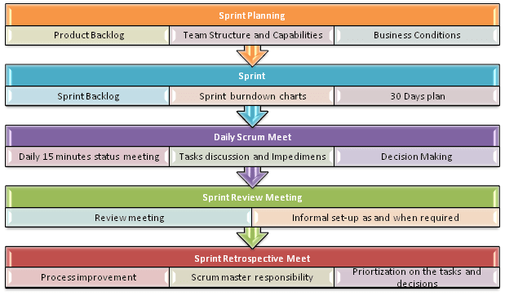
We have elaborated in the following sections to ensure we demonstrate our knowledge and experience in delivering large scale and complex automated business process solutions.

Stage 1: Business Analysis & Design
During this stage; ANKABUT consultants will perform business requirement sessions with functional owners of the applications to collect the business requirements for the targeted applications to be developed.
The following table summarize the main activates and deliverables that will be performed during this stage:
Main Activity | Main Deliverables
- Perform business requirements sessions with stakeholders and generate SRS documents.  - Identify integrations requirements.  - Identify system architecture requirements | - SRS documents  - Architecture & Design document

Stage 2: Collaborative Application Development
Based on information gathered in stage 1, the BA creates an application in collaboration with the business user's project team. Then, iterations (sprints) are made based on the inputs received from the business user to ensure the application's smooth functionality. A series of workshops (sprint review) are conducted during collaborative app development. After every review stage, the product owner moves on to the next stage of application development.
The following table summarize the main activates and deliverables that will be performed during this stage:
Main Activity | Main Deliverables
- Perform development activities and unit test  - Perform Functional & Integration test  - Perform System demo (Sprint Review) with Product Owner (BA) and KUEC Business Owner  - Identify Business Use Cases  - Prepare Environment for UAT | - Sprint Review document’s  - User Acceptance Test Scenarios document

Stage 3: Validation and System Acceptance
After successfully developing and reviewing the application prototype, the objective in this stage is to implement all the required changes.
- Application enhancements are made through configuration, customization, and integration.
- The business user validates changes.
- The application is submitted for validation, testing, and sign-off by the business user's project team.
The following table summarize the main activates and deliverables that will be performed during this stage:
Main Activity | Main Deliverables
- Prepare users for Testing  - Perform UAT execution cycle (1st and 2nd rounds)  - Prepare Environment for Go-live | - UAT Sign-Off certificate  - System Manuals

Stage 4: Training & Enablement
Training is one of the most important tasks performed during any project. If the project team is not sufficiently trained, they cannot provide adequate assistance during the project and a risk exists that the end solution will not meet all requirements. If the end-users are not adequately trained, then they will not be able to use the system even if the solution itself is perfect.
The following table summarize the main activates and deliverables that will be performed during this stage:
Main Activity | Main Deliverables
- Perform End-User Training (Train the Trainer)  - Perform System Administrator Training  - Perform Low-Code Development Technical Training | - Training Sign-Off certificate

Stage 5: Production Setup & Data Migration
This is the last stage, and it will execute in Parallel with stage 4. The team will make sure production environment readiness, take the completed solution from staging into production, and validate that the system is tested systematically and is available for end users.
The following table summarize the main activates and deliverables that will be performed during this stage:
Main Activity | Main Deliverables
- Deploy Solution on Production  - Perform Smoke Test  - Set up adequate support staff  - Determine the cutoff time & go-live date | - System Deployed and ready for Go-Live

Stage 6: Go-live Support & Closure
Upon delivery and acceptance of the above; ANKABUT will commence the Stabilization stage. This stage lasts for 1 month (separated into two weeks after the end of each implementation phase) after going live. During this stage, teams and users often meet once in the morning and in late afternoon to discuss problems and answer questions that may arise. The questions to be answered during this stage may range from how the system is working, and system stability. Also required during this stage is the monitoring of the infrastructure for response times and to ensure backups are taken appropriately for all hardware and software.
Main Activity | Main Deliverables
- System Support  - Handle issues and bugs  - Perform corrective actions  - Status meeting with KUEC users  - Provide guidance to KUEC users  - Monitor system performance | - Go-Live Acceptance

Option 2 : Odoo-based ERP Platform

RFP Compliance Matrix & Feasibility Summary
The following Compliance Matrix provides a line-by-line assessment of KUEC’s functional and technical requirements against Odoo 18 Enterprise Edition. For each item, we indicate one of four feasibility states:
Indicator | Meaning | Typical Effort
Standard | Fully supported by Odoo (configuration only). | Basic configuration & onboarding
Development | Achievable through customization in Odoo (Python/OWL, Studio, or bespoke modules). | Moderate development & QA
Integration | Requires interfacing Odoo with an external system or third-party service. | API work, middleware, testing
Gap / No | Not available in native Odoo. Substantial custom development or alternative tooling would be required. | Significant project scope
Important clarification:
Whenever the matrix shows “No,” it denotes that the requested capability does not exist in Odoo’s standard feature set. Achieving that requirement would therefore necessitate either (a) a dedicated custom module that extends Odoo far beyond typical configuration, or (b) the adoption of a specialist third-party platform.
This structured view enables KUEC to quickly gauge feasibility, budget impact, and risk for each requirement, ensuring transparent expectations before project kickoff.

Registration & Approval

Req ID | Requirement Description | Covered in Odoo? | Odoo Fit
1 | Start-up Registration (portal form & docs) | Yes | Standard
2 | Start-up Registration Approval workflow | No | Development
3 | Start-up Sign-Up / Portal onboarding | No | Development
4 | Service Vendor Registration | No | Development
5 | Vendor Approval by Procurement | Yes | Standard
6 | Vendor Account Activation & Dashboard | Yes | Standard
7 | Automatic Notifications on registration | Yes | Standard
8 | Cancel / Disqualify Start-up (≤ 1 yr) | No | Development
9 | Cancel Approved Vendor & final billing | No | Development

Operational Model
Req ID | Requirement Description | Covered in Odoo? | Odoo Fit
10 | Customer profile & segmentation | No | Development
11 | Vendor classification & star rating | No | Development
12 | Service/package pricing with discounts | Yes | Standard
13 | Smart service-to-vendor routing | No | Development
14 | Onboarding package (22 services) | No | Development
15 | Service catalogue browsing | Yes | Standard
16 | Business-matrix eligibility rules | No | Development
17 | Purchase package/request quotation | Yes | Standard
18 | CRM update after purchase | Yes | Standard
19 | Auto / manual service assignment | No | Development
20 | Fulfilment journeys (project & retainer) | No | Development
21 | SR communication thread & docs | Yes | Standard
22 | Customer satisfaction survey | Yes | Standard
23 | Iterative service-card deployment | No | Development
24 | Service cancellation & refund flow | No | Integration
25 | Wallet/card refund (on-time payers) | No | Development
26 | Invoice cancellation (on-account) | Yes | Standard

Customer Support
Req ID | Requirement Description | Covered in Odoo? | Odoo Fit
27 | Chat widget & ticket logging to CRM | Yes | Standard
28 | Auto SR creation (chat / call) & merge | Yes | Standard
29 | SR reassignment & team views | Yes | Standard

Reporting & Analytics
Req ID | Requirement Description | Covered in Odoo? | Odoo Fit
30 | Revenue tracking (monthly/yearly) | Yes | Standard
31 | Revenue by vertical / parameters | Yes | Standard
32 | Tracking & cost codes | Yes | Standard
33 | P&L per account | Yes | Standard
34 | SLA compliance reports | No | Development
35 | Support-transaction volumes | Yes | Standard
36 | Backlog SRs exceeding SLA | Yes | Standard
37 | Customer-satisfaction dashboard | Partial | Standard + Integration

Core Interfaces & Integration
Req ID | Requirement Description | Covered in Odoo? | Odoo Fit
I-1 | Enterprise CRM workspace | Partial | Standard + Development
I-2 | Vendor portal (registration, KPIs, payments) | No | Development
I-3 | Customer self-service portal | Partial | Standard + Development
I-4 | ERP/API integrations & scalability | No | Integration
Note:
“Covered in Odoo? = No” indicates that the capability is not available in Odoo out of the box and will need either custom development or an external integration to meet KUEC’s specification.

Odoo Standard Possible Utilization – Tailored to KUEC Center of Excellence (CoE)
In this section, we show how the core Odoo 18 Enterprise apps can be linked together. like stations on a single track to support KUEC’s end-to-end Shared-Services Portal life-cycle:
- Registration & Screening (Website Forms → Portal → CRM)
- Service Catalogue & Ordering (eCommerce / Sales → Subscriptions)
- Service Fulfilment (Project / Helpdesk / Field Service)
- Vendor Collaboration & Procurement (Purchase → Invoicing)
- Finance & Reporting (Accounting → Spreadsheet → Power BI)
- Customer Support & Satisfaction (Discuss → Survey)
- Governance & Compliance (Documents, Approvals, Studio)
Rather than listing features in isolation, we kept each BRD requirement in view, mapped it to the closest out-of-the-box module, and described the hand-off that occurs when data moves from one module to the next. The objective is a practical playbook that shows where configuration alone delivers value, and where customization or external integration is unavoidable.

Registration & Screening
BRD Theme | Odoo Flow (Standard) | Key Built-in Features
Start-up / Vendor On-Boarding | Website > Form Builder captures registration data > auto-creates Partner record in Contacts > routes to CRM stage “Screening”. | CAPTCHA, attachment upload, GDPR consent, Server Action emails, Innovation & Procurement teams.
Approval Gate | Reviewer moves record to “Approved” stage; Approvals app logs decision & comments. | Multi-level approvals, activity scheduling, full audit trail.
Portal Activation | Portal invitation sent automatically; registrant sets self-password, sees personalized dashboard. | Single Sign-On (SAML/OAuth optional).
Auto-Notify | Automated Actions trigger system mails/chatter messages on stage change. | HTML templates per actor (Start-up, Investor, Vendor).

Service Catalogue & Ordering
BRD Theme | Odoo Flow (Standard) | Key Built-in Features
Catalogue Browsing | Website Shop / eCommerce lists “Service Packages” filters by Governmental vs Non-Governmental, Delivery Mode, and Eligibility. | Pricelists, attribute filters, -and multi-currency.
Eligibility Matrix | The portal user enters or already holds tags (“Subsidiary”, “Startup”). Website Builder shows only eligible items via the Domain filter. | Dynamic publish rules; no code needed.
Package Subscription / Retainer | “Subscribe” button converts to Sales → Subscription contract with billing cycle (monthly/annual). | Automatic invoicing, payment tokens, and renewal alerts.
Quote for Project-Based Service | RFP button opens Sales Quotation form; CoE Coordinator completes scoping; quote emailed to customer. | Sign on quote: online payment of deposit.

Service Fulfilment & Task Management
BRD Theme | Odoo Flow (Standard) | Key Built-in Features
Project-Based Services | Sales Order confirmation spawns a Project with tasks & milestones. | Gantt / Kanban views, project profitability.
Retainer / Ticketed Services | Subscription auto-creates a Helpdesk ticket each month, OR lets the customer raise an SR manually in the Portal. | SLA timers, timesheets, and billable hours.
22-Step Onboarding Package | Pre-configured Project Template (22 tasks) imported at startup profile approval. | Task checklist widget, progress bar.
Service Communication Thread | Every task/ticket has its own Discuss channel; vendor staff are added as followers from the Vendor Portal. | File sharing, emoji, @mentions.
Customer Satisfaction | On task/ticket closure, the Survey app auto-sends a 5-point CSAT form; scores feed Kanban ‘Happy / Neutral / Unhappy’. | Conditional questions, dashboard.

Vendor Collaboration & Procurement
BRD Theme | Odoo Flow (Standard) | Key Built-in Features
Vendor Registration & Rating | Vendor record created, Purchase tags hold Service Categories; custom “Stars” field via Studio. | Vendor pricelists, scorecards.
Smart Routing | Python rule (custom) assigns incoming SR to preferred vendor; rule taps vendor category & star rating. | (Custom logic sits on top of Purchase / Project).
PO & 3-Way Match | CoE Coordinator approves vendor’s proposal > auto-creates Purchase Order > Goods Receipt > Vendor Bill matched. | Duplicate-bill blocking, price variance warnings.

Finance, Wallets & Reporting
BRD Theme | Odoo Flow (Standard + BI) | Key Built-in Features
Billing & Refunds | Subscription invoices auto-post to Accounting; credit-note wizard handles cancellations; payment acquirer refunds card (API). | Payment tokens, multi-currency, and Partial refunds.
On-Time Payer Wallet | Simple “Wallet” analytic account holds credit balance; applied on next invoice (custom but lightweight). | Analytic defaulting, negative invoice lines.
Revenue / Cost / P&L | Spreadsheet template pulls live data from Accounting, Purchase; publishes to Power BI via connector. | Pivot caching, scheduled exports.
SLA & Backlog KPIs | Helpdesk KPIs exposed via Odoo’s /JSON RPC; Power BI dataset refreshes nightly. | Native SLA statistics, tag filtering.

Customer Support & Live Chat
BRD Theme | Odoo Flow (Standard + Integration) | Key Built-in Features
Live Chat Widget | Odoo Live Chat embeds on portal pages; on the/helpdesk channel, join it creates a ticket automatically. | Chatbot hand-over, canned replies.
Call Logging | Odoo VOIP module logs inbound calls; missed call triggers a Helpdesk ticket. | Asterisk / SIP integration.
Ticket Merge | Built-in “Merge Tickets” wizard groups duplicates; SLA clock preserves the oldest timestamp. | Drag-drop merge, chatter history preserved.

Governance, Documents & Approvals
BRD Theme | Odoo Flow (Standard) | Key Built-in Features
Service Cards & Version Control | Each service has a Product Template; CoE Admin edits via Studio; revisions are tracked in Documents. | Check-in/out, versioning.
Digital Approvals | Approvals app routes POs, price exceptions, vendor onboarding forms; fully timestamped. | PDF attachments, resubmit loop.
Policy & License Repository | All master data (licenses, policies) are stored in Documents with expiry alerts 60 days prior. | Access groups, tag search.

Why It Matters for KUEC
- Faster Go-Live – 80 % of the CoE requirements align with native Odoo workflows; configuration delivers value before custom code starts.
- Single Source of Truth – Contacts, SRs, projects, invoices, and surveys all share the same database, cutting manual reconciliations.
- Scalable Roadmap – Future AI routing, vendor chatbots, or advanced BI dashboards can plug into the same API layer with minimal refactoring.
Whenever a BRD line item genuinely exceeds standard capability, we have flagged it in the Compliance Matrix as Development or Integration; otherwise, the tables above demonstrate how Odoo Standard can be deployed immediately to cover core CoE processes.

Data-Migration & Cleansing Plan
We will migrate all legacy customer, vendor, and service‑catalogue data into Odoo in a three‑wave approach:
Wave | Source Systems | Target Models | Cleansing & Validation Steps | Owner
1 | Excel master lists (Start-ups, Subsidiaries, Vendors) | (Contacts) incl. tags for Eligibility & Customer Class | • Remove duplicates• ISO address / phone format• Emirate & license-number regex checks | KUEC Data + Ankabut
2 | Current SR tickets (SharePoint / Mailbox) | helpdesk. Ticket + attachments | • Map old categories to new Service Codes• Auto-assign historic SLA outcomes | Ankabut
3 | Historical invoices & vendor bills (ERP) | account.move | • Balance control accounts• Tie to analytic tags for cost center P&L | KUEC Finance

Integration Architecture
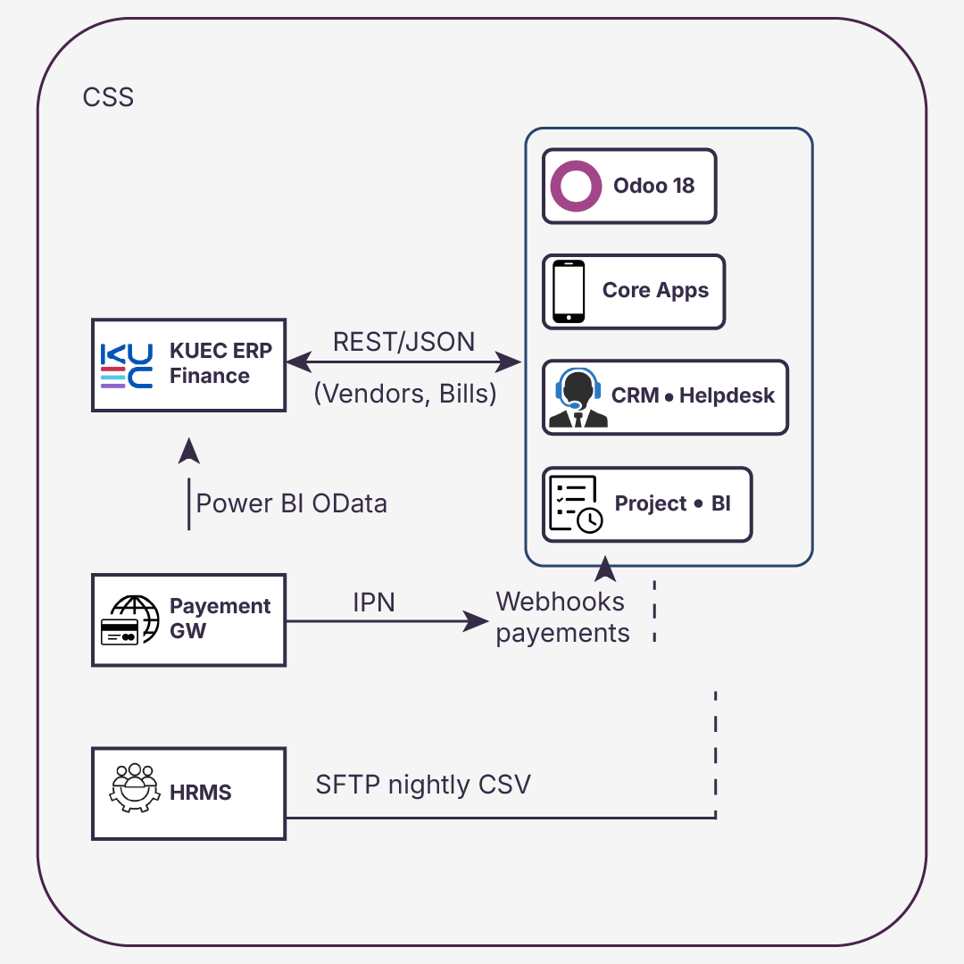

Training Approach: “Explain → Show → Do → Coach”
Ankabut will deliver a structured training program to ensure all KUEC user groups—internal teams, vendors, and customers—are confident and self-sufficient in using the new portal and back-office system. Our approach is based on the “Explain → Show → Do → Coach” model, which maximizes both knowledge retention and real-world application.

Phase 1: Explain
We begin each training module by clearly explaining the why and what behind the system feature or process.
- 10–15 minute briefing sessions aligned to real KUEC use cases (e.g., registering a startup, routing a service request).
- Delivered live or pre-recorded via Google Meet.
- Materials: PDF Quick Reference Guides, Arabic & English.

Phase 2: Show
Next, we demonstrate the feature live in the system, using Demo data and the actual KUEC configuration.
- Step-by-step walkthroughs in Odoo (e.g., confirming a purchase order, responding to a vendor quote).
- Recorded screen shares added to KUEC’s internal training library.
- Split by role: CoE Coordinator, MIS Analyst, Vendor, Customer.

Phase 3: Do
Users then practice the process themselves inside the UAT (test) environment.
- “Role-play” exercises: simulate SR routing, service delivery milestones, vendor invoice processing.
- Users follow the process with guidance materials but without intervention.
- Hands-on tasks are tracked via checklists to monitor progress and identify knowledge gaps.

Phase 4: Coach
Finally, our trainers observe and provide 1:1 or small-group coaching sessions to reinforce learning.
- Shadowing during the pilot phase (e.g., watch the first vendor onboarding or ticket resolution).
- Corrections and tips offered live, with a follow-up summary sent to each participant.
- This phase continues into Week 1 of go-live as part of the Hypercare plan.

Training Schedule Snapshot:
Audience | Training Format | Language | Duration | Materials
CoE Coordinators | Live + recorded | EN/AR | 3 x 1.5h | Role manual, videos
Vendors | Video + sandbox tasks | EN/AR | Self-paced | Portal guide, checklist
Internal Departments | Live session + follow-up | EN/AR | 1 x 2h | Process map, SOP
Startups / Customers | Walkthrough videos in the portal | AR preferred | < 10 min each | FAQ, in-app video
This model ensures each user learns not just where to click, but when, why, and what to do next, reinforcing KUEC’s vision of a modern, intuitive, and service-focused digital experience.

Assumptions & Exclusions
# | Assumption / Exclusion | Impact if False
A1 | Legacy data provided in agreed format before Sprint 1 | Timeline slip ≈ 1 week
A2 | Payment gateway onboarding starts in Week 1 | Delay in go-live payments
E1 | Arabic translations for UI provided by KUEC | Minor delay in UI delivery

SLA & Support Model
Tier | Example | Response | Resolution | Escalation
L1 | Password reset | 1 h | 4 h | –
L2 | Minor bug | 4 h | 1 bd | L3 after 8 h
L3 | Outage | 30 min | 4 h | CTO

Project – Option 2 Implementation Plan & Timeline
This section outlines our proposed compressed implementation roadmap, designed to deliver the entire KUEC CoE Shared Services Portal in under 2 calendar months.
Rather than spreading delivery across traditional agile sprints, we have structured the work into four functional implementation tracks, each with focused teams working in parallel to accelerate time to value.
The schedule is anchored to a 2 September 2025 kickoff. All milestones are subject to adjustment based on KUEC resource availability, data readiness, or integration partner alignment.

On-Site Discovery First
The project begins with a 5-day on-site Discovery & Alignment workshop during the first week of September. This workshop is attended by key stakeholders across CoE Coordination, MIS, Procurement, and Finance.
Objectives include:
- Finalizing scope and ownership per the BRD requirement
- Validating data structure, user stories, and business rules
- Confirming acceptance criteria and reporting expectations
This ensures that the upcoming configuration and development work is rooted in real user context, reducing risk and rework.

Functional Delivery Tracks
Track | Duration | Key Deliverables
Track 1: Registration & Interfaces | 2 Sept – 27 Sept | Startup/vendor registration flows, approval engine, portal activation, role-based views (Customer, Vendor, CoE Coordinator)
Track 2: Catalogue & Logic | 2 Sept – 30 Sept | Service catalogue (gov + non-gov), subscription model, pricing rules, eligibility filters, smart routing logic
Track 3: Fulfilment & Support | 9 Sept – 10 Oct | Onboarding packages, project-based and retainer fulfilment journeys, helpdesk workflows, and customer satisfaction surveys
Track 4: Finance & Reporting | 16 Sept – 28 Oct | Wallet & refund engine, invoice logic, integration touchpoints (ERP & payment), Power BI datasets (SLA, revenue, CSAT)

Key Milestones & Timeline
Date | Milestone
2 Sept 2025 | Project Kickoff & Discovery Workshop
13 Sept 2025 | Registration Module UAT Start
25 Sept 2025 | Catalogue Logic Fully Configured
10 Oct 2025 | Fulfilment & Support Demo Sign-Off
20 Oct 2025 | Finance Logic Ready for Validation
28 Oct 2025 | Full System Go-Live
1–15 Nov 2025 | Hypercare, knowledge transfer, and Go-Live extension to all users

Execution Principles
- Parallel teams are assigned per track to maximize velocity
- Shared project board (Odoo Project) visible to KUEC and Ankabut team for daily tracking
- Weekly RAID log reviews with KUEC leadership
- All major releases are tested and staged on UAT before go-live
- Arabic and English UI/UX validated in each module

Implementation Scope, Integrations, and Catalogue Rule Enforcement
This section outlines the work that will be delivered, the estimated effort and timeline, the third-party systems involved, and the technical approach for enforcing KUEC’s Service Catalogue rules within Odoo. It also identifies any non-standard coverage and clarifies which updates can be managed by administrators versus those requiring developer involvement.

Scope of Work
Scope Item | Approach | Description | Effort (Days)
Service Catalogue Filters | Custom | Implement filters for Governmental/Non-Governmental, Delivery Mode, Eligibility, and Service Code within the portal and shop. | 4
Smart Routing Rules | Custom | Automatically assign vendors based on category, rating, and eligibility criteria. | 3
Onboarding Checklist | Custom | 22-step onboarding checklist linked to service requests and SLA tracking. | 4
Retainer Fulfilment Flow | Config + Custom | Automate recurring service requests with SLA monitoring. | 5
Dispute Resolution View | Config + Custom | Portal view for managing disputes with escalation paths. | 3
Customer Support Chat & Ticket Merge | Custom | Embedded chat tool with the ability to create service requests and merge duplicate tickets. | 4
Vendor Payment & CSAT Dashboard | Config + Custom | Vendor portal section for viewing payments and customer satisfaction scores. | 3
Admin Catalogue & Rule Configuration | Config + Custom | Administration screens to manage eligibility rules, pricing, and vendor routing logic. | 4

Effort and Timeline
The total estimated effort is approximately 30–35 Man-days. Delivery will follow the schedule already outlined in the Project Implementation Plan & Timeline section, anchored to a 2 September 2025 kickoff and a go-live date of 28 October 2025.
The implementation will be delivered within the same milestones, including:
- Parallel delivery across functional tracks (Registration & Interfaces, Catalogue & Logic, Fulfilment & Support, Finance & Reporting).
- Completion of all configurations, custom developments, integrations, testing, and training within the 2-month delivery window.

Third-Party Systems and Integrations
System | Method | Purpose | Key Risks
Payment Gateway (e.g., Network International) | REST API via Odoo Payment Acquirer | Process online payments | Possible downtime or SLA delays
Government Systems (status checks, validation, licensing) | If API is provided: Direct REST/SOAP integration using Odoo’s standard API framework (XML-RPC/JSON-RPC). If no API is provided, Manual data exchange or upload/download through the portal. | Automate service status checks, license verifications, and other regulatory validations. | Dependency on government API availability, authentication changes, or data format updates.
Document Verification Services | REST API via Odoo connector | Validate trade license and compliance documentation | Changes to API specifications
Power BI | OData/SQL connector from the Odoo database | Provide BI dashboards and analytics | Data refresh or connection failures

Catalogue Updates – Administrator vs Developer Control
Update Type | Admin | Developer
Service descriptions, pricing, eligibility lists, categories | ✔ | —
Adding or removing services | ✔ | —
Adjusting vendor assignments in routing rules | ✔ | —
Adding new attributes to the service code structure | — | ✔
Changing the logic behind smart routing | — | ✔
Adding new third-party integrations | — | ✔

Operational Workflow Mapping Overview
To complement the technical scope and catalogue enforcement plan, the following tables map KUEC’s core service fulfilment workflows directly to Odoo 18 Enterprise features. Each step in the process is shown with its corresponding Odoo module, whether it is delivered using standard functionality or requires customization, a description of its function in the workflow, key technical details, and the expected outcome. This ensures full transparency on how day-to-day operations will be executed within Odoo and where development effort will be focused.

Operational Workflow Mapping – Retainer / Service Package Fulfilment in Odoo
Step / Condition in Flow | Odoo Module / Feature | Type | Function in Workflow | Technical Details | Outcome
1. Select the service package | Website / Portal + Custom Service Catalogue | Custom + Config | The customer chooses a service package from the portal. | Portal pulls records from service.catalogue.item model, eligibility, and delivery mode filters are applied dynamically. | Ensures that customers only see valid packages for which they are eligible to request.
2. Select service duration (monthly/annual) | Subscription | Standard | Capture subscription length. | Duration field tied to subscription template linked to selected service. | Automates billing cycle setup.
3. Accept terms & conditions | Website Checkout | Config | Customer agrees to the service T&Cs. | A mandatory checkbox field is stored on the sales order, preventing submission if it is not checked. | Legal acceptance is logged in the backend.
4. Sign predefined service contract | eSign / Documents | Standard | Sign the contract before payment. | Contract template pre-filled with customer/service details; eSign workflow initiated. | Signed PDF stored in Odoo Documents.
5. Pay for the service | Website Payment | Standard | Process payment online. | The integrated payment gateway processes the transaction; Odoo updates the payment status. | Immediate confirmation of payment.
6. Receive confirmation & receipt | Invoicing / Email | Standard | Send proof of purchase. | Auto-generated invoice emailed; chatter post on sale order with PDF attached. | Transparent financial documentation.
7. Notify L1 CoE Coordinator | Discuss / Activity | Standard | Alert the coordinator for action. | Activity is auto-created in the coordinator's to-do list upon payment confirmation. | The coordinator is ready to initiate package confirmation.
8. Perform package confirmation call | CRM / Activities | Standard | Verify order details with the customer. | Call logged as CRM activity linked to subscription; notes stored in Chatter. | Confirms accuracy before fulfillment.
Condition: Successful? | — | — | Decision point. | If “No”, triggers meeting (Step 9); if “Yes”, moves to vendor notification (Step 11). | Logical branching in process.
9. Meeting with requester | Calendar / Meetings | Standard | Resolve unclear details. | Meeting scheduled in Odoo Calendar with the requestor & coordinator. | Aligns expectations before fulfilment.
Condition: Purchase confirmed? | — | — | Decision point. | If “No”, refund process initiated (Step 10). | Avoids wasted vendor effort.
10. Start the refund process | Invoicing / Accounting | Standard | Reverse transaction. | Credit note issued; payment reversal triggered in the payment. | Customer refunded, process closed.
11. Automatic vendor notification for fulfilment | Project / Task Assignment | Custom Automation | Assign a vendor to deliver the service. | Rule-based routing assigns vendor tasks in the project module based on service attributes. | Fast and accurate fulfilment assignment.
12. Serve deliverables | Project / Documents | Standard | Complete and deliver work. | Vendor updates project task; uploads deliverables to Documents. | Deliverables are accessible to the customer.
13. Capture customer feedback | Survey / Rating | Standard | Collect post-service feedback. | Survey auto-sent upon task completion; results stored in service request record. | Customer satisfaction metrics captured.
Condition: Positive? | — | — | Decision point. | If “No”, triggers feedback call (Step 14). | Enables service recovery.
14. Perform feedback call | CRM / Activities | Standard | Resolve customer concerns. | Call scheduled and logged as CRM activity linked to SR. | Builds trust, attempts issue resolution.
Condition: Issue resolved? | — | — | Decision point. | If “Yes”, end process; if “No”, escalate to vendor performance meeting (Step 15). | Clear escalation path.
15. Performance management meeting with vendor | Calendar / Meetings | Standard | Address vendor performance. | Meeting logged against vendor record; minutes stored in Documents. | Drives vendor accountability.
Condition: Issue resolved? | — | — | Decision point. | If “No”, escalate to investigation meeting (Step 16). | Maintains escalation discipline.
16. Investigation meeting with vendor | Calendar / Meetings | Standard | Conduct detailed investigation. | Meeting notes stored; corrective actions assigned in project tasks. | Identifies root cause.
Condition: Issue resolved? | — | — | Decision point. | If “No”, start vendor change process (Step 18). | Final escalation step.
17. End process | — | — | Process closure. | Mark service request as complete in backend. | Ensures data accuracy.
18. Start vendor change process | Purchase / Vendor Management | Custom + Config | Replace underperforming vendor. | Vendor deactivated; routing rules updated to exclude vendor. | Service continuity maintained.
19. Notify L2 CoE Coordinator | Discuss / Activity | Standard | Inform management of change. | Automated message to L2 coordinator. | Transparency in escalations.

Operational Workflow Mapping – Project-Based Service Fulfilment in Odoo
Step / Condition in Flow | Odoo Module / Feature | Type | Function in Workflow | Technical Details | Outcome
1. Filling the service request form | Website / Portal + Custom Service Request model | Custom + Config | Entry point for project-based work. | Portal form linked to service.request model; dynamic filters from Service Catalogue; file uploads to Documents. | Captures all essential project request data.
2. Review the scope | Project / CRM Activity | Standard | Validate initial request. | Coordinator reviews form data in project record; flags missing details. | Prevents unclear scopes from proceeding.
Condition: Scope is clear? | — | — | Decision point. | If “No”, schedule meeting (Step 3); if “Yes”, go to draft scope (Step 4). | Early clarity.
3. Meeting between requestor, CoE, and vendor | Calendar / Meetings | Standard | Clarify scope with all parties. | Meeting scheduled and linked to service request record. | Aligned understanding of requirements.
4. Draft the final scope document | Documents / Project | Standard | Prepare detailed scope. | Vendor/coordinator uploads scope file in Documents; linked to project. | Scope version control in place.
5. Process the scope amendments | Documents / Project | Standard | Update scope after feedback. | New document versions uploaded; tracked in chatter. | Traceable scope changes.
6. Scope document approved? | Approvals | Standard + Config | Formal approval workflow. | Approval request sent to designated approvers; logged decision. | Authorized scope before contracting.
Condition: Approved? | — | — | Decision point. | If “No”, return to amendments (Step 5); if “Yes”, go to Step 7. | Prevents unauthorized work.
7. Adding scope to pre-approved service contract template | eSign / Documents | Standard | Merge scope with contract. | Contract auto-generated with approved scope details. | Single source of truth for agreement.
8. Initiate contract signature process | eSign | Standard | Get signatures from all parties. | eSign request sent; status tracked in backend. | Legally binding contract executed.
9. Contract signature | eSign | Standard | Confirm readiness to start project. | Signed PDF stored in Documents; project status updated to “Active”. | Clear project commencement signal.
10. Project deliverables | Project | Standard | Execute work as per scope. | Vendor updates tasks, logs time, and attaches deliverables. | Progress and outputs recorded.
11. Deliverable review | Project / Quality Check (custom step) | Standard + Custom | Validate deliverables. | Coordinator reviews and approves/rejects deliverables in project. | Quality control before closure.
Condition: Approved? | — | — | Decision point. | If “No”, request modifications (Step 13); if “Yes”, close project. | Controlled acceptance.
12. Ask for modification | Project Task | Standard | Request changes from vendor. | Task moved to “In Progress”; comments in chatter. | Vendor clear on changes needed.
13. Process the amendments | Project Task | Standard | Implement change requests. | Vendor updates deliverables; attaches revised files. | Rework tracked.
14. Initiate alignment meeting with all parties | Calendar / Meetings | Standard | Ensure all agree on final deliverables. | Meeting scheduled; notes stored in Documents. | Consensus before final approval.

Appendix C — Proposed UI Mockups (Odoo 18 EE Theme)
The following visuals present conceptual user interface mockups of the KUEC Center of Excellence Self-Service Portal, designed in the official Odoo 18 Enterprise style.
They illustrate the complete workflow from portal entry to service request fulfilment, support, and administrative configuration.
Each mockup directly maps to functional requirements in the BRD and Service Catalogue, making it easier for all stakeholders to visualize how the proposed solution will look and operate.

Figure 01 — Portal Landing Dashboard
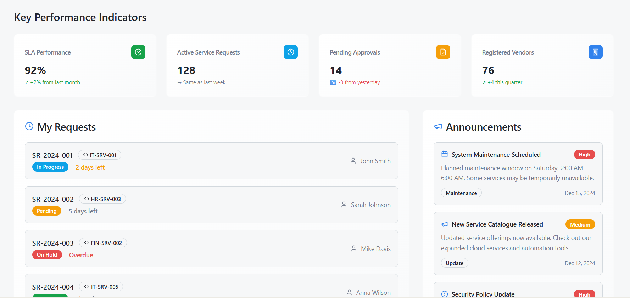

Figure 02 — Customer Registration (Start-Up)
Purpose: Allows new startup customers to register, upload compliance documents, and submit for eligibility screening. Progress bar shows completion (Company Profile → Documents).
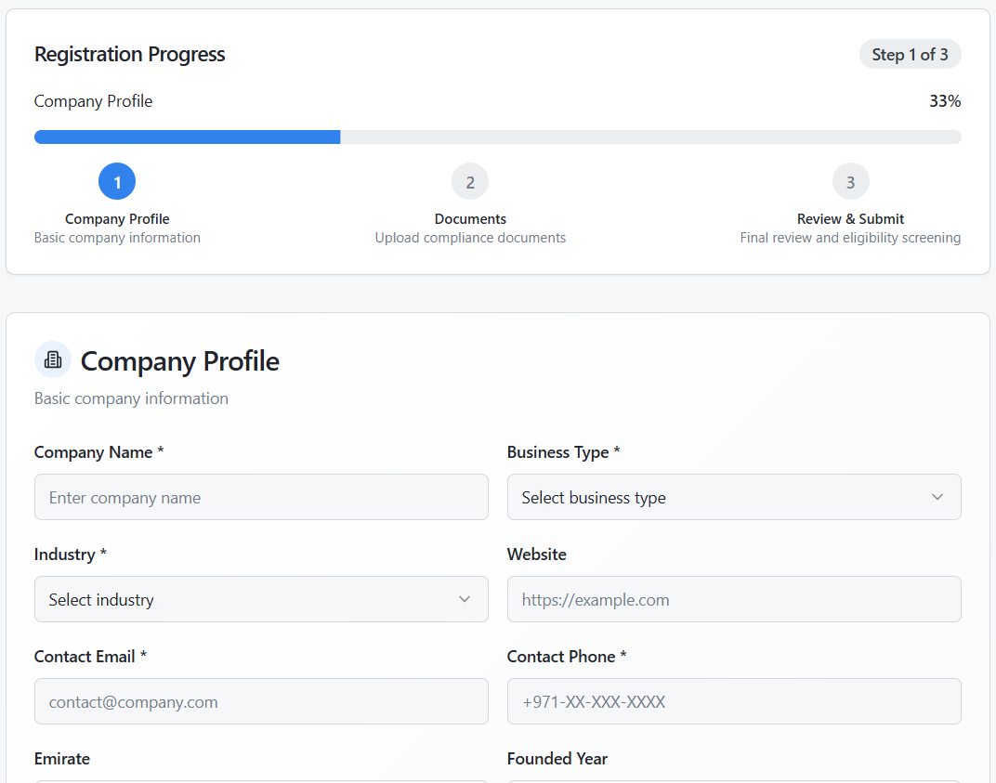

Figure 03 — Service Catalogue (Governmental & Non-Governmental)
Purpose: Let customers browse available services with filters for type, delivery mode, and eligibility. Each service card shows Service Code, title, and pricing, with a link to full details.
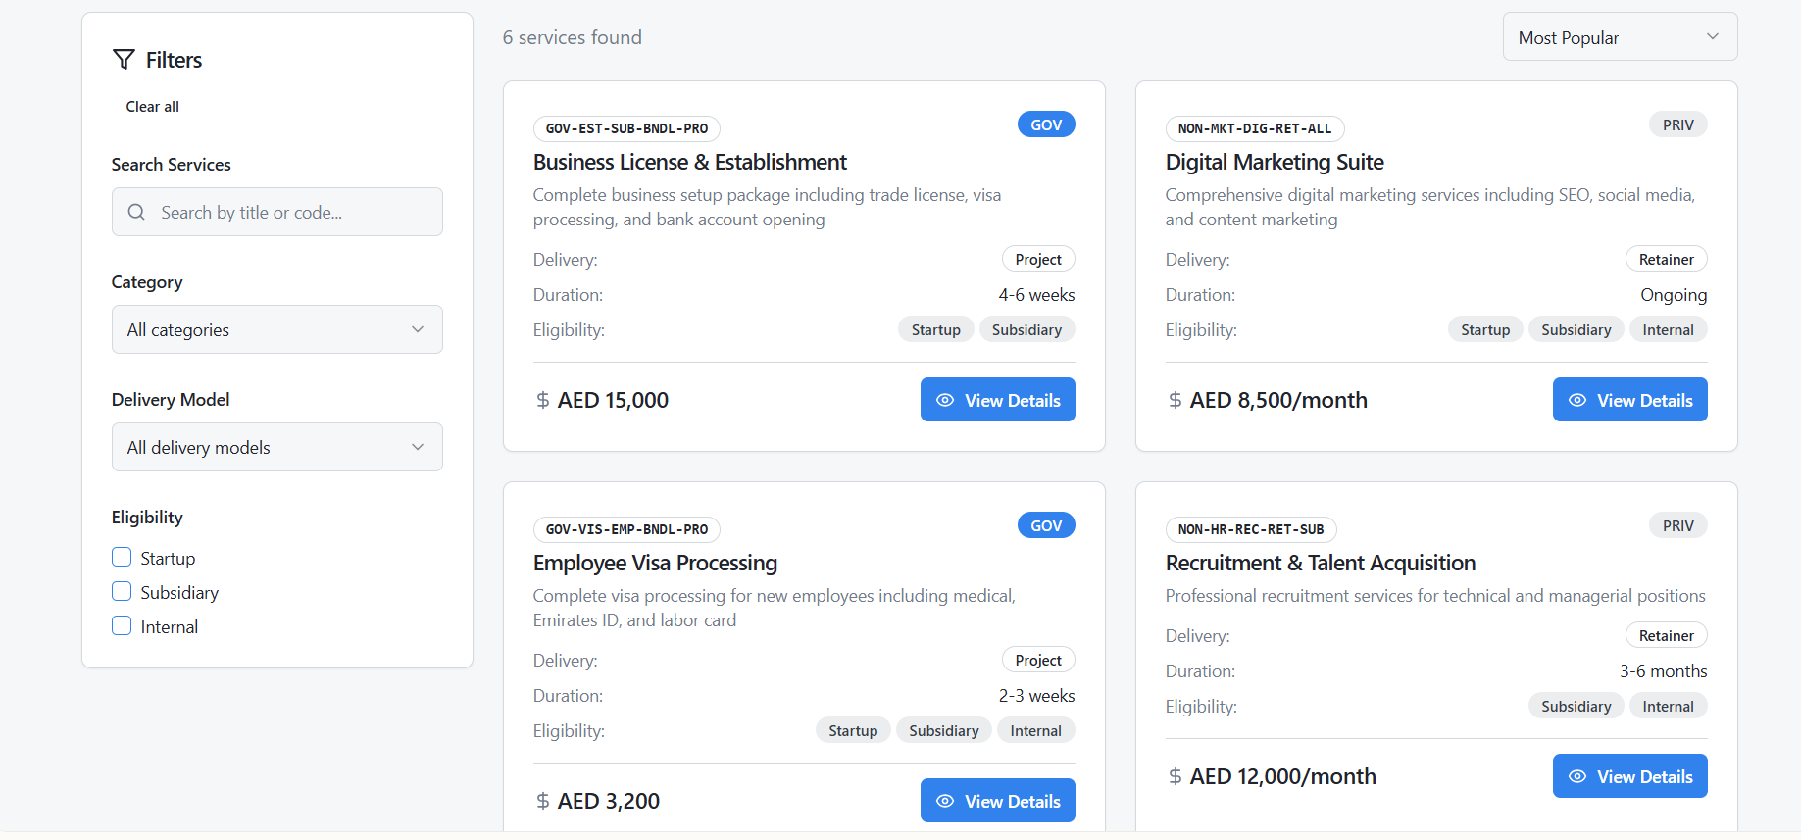

Figure 04 — Create Service Request
Purpose: Form to submit a new request. Supports Project-Based (scope, target date, budget) or Retainer (billing cycle, start date, wallet credit) modes.
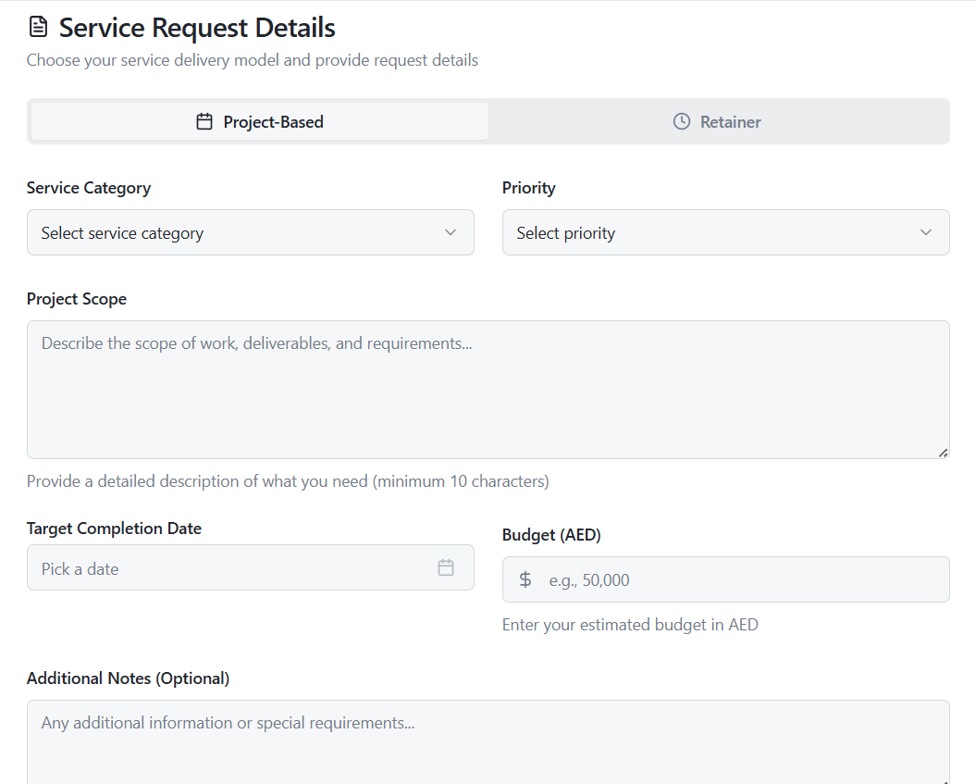
Figure 05 — Vendor Payments & CSAT
Purpose: Vendor view to track scheduled/paid payments linked to service milestones and review customer satisfaction scores by service.
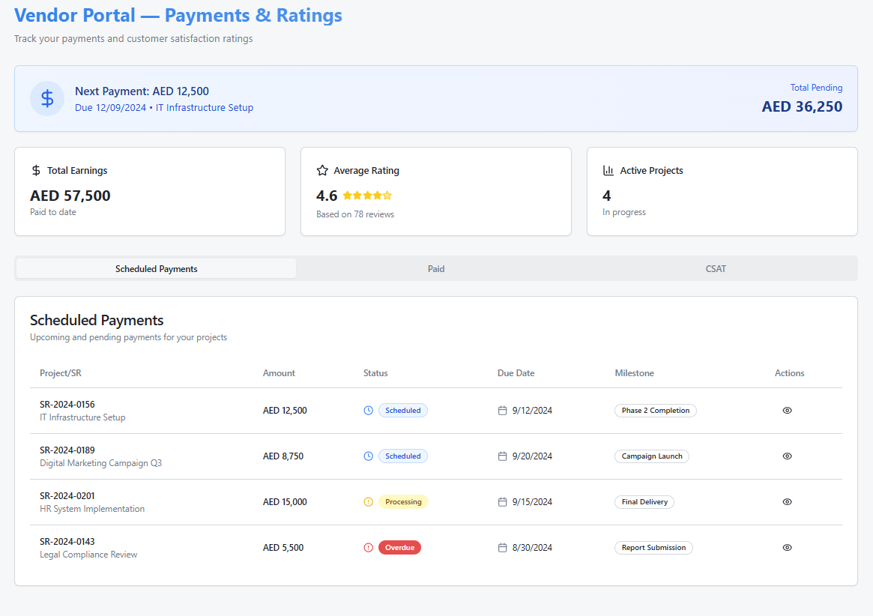
Figure 06 — Dispute Resolution Case
Purpose: Central case view for disputes between customer and vendor. Shows threaded communications, linked SR, reason, SLA target, and escalation actions.
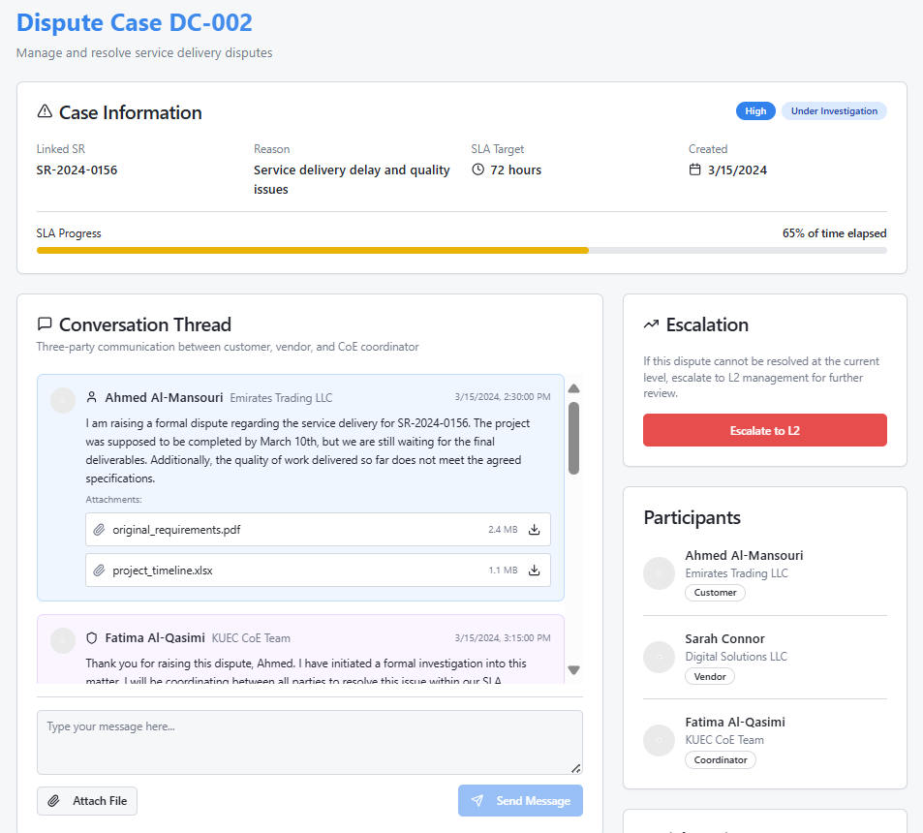

Figure 07 — Project-Based Fulfilment Orchestration
Purpose: Visualizes the workflow of project-based services. Kanban columns (To Do, In Progress, Review, Done) show task stages; right mini-Gantt shows timelines.
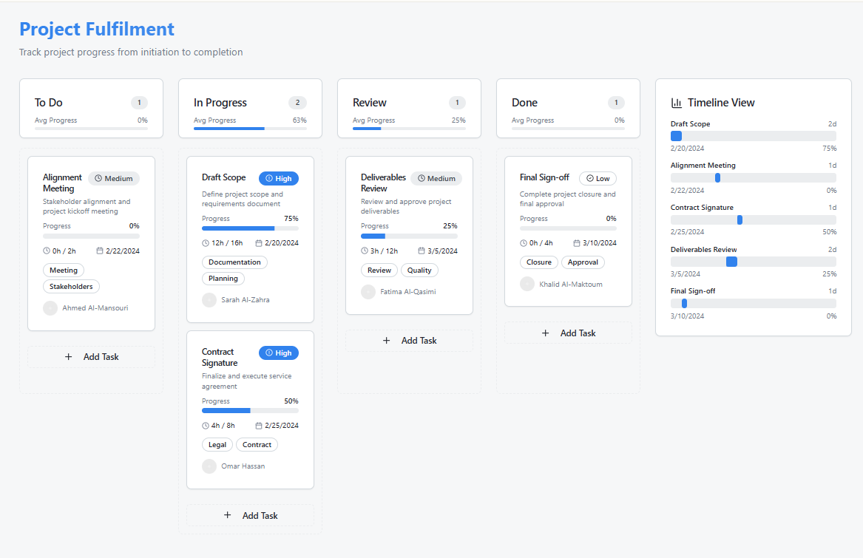
Figure 08 — Retainer Fulfilment Orchestration
Purpose: Displays recurring service tickets grouped by month. SLA compliance shown with green/amber status pills; includes vendor assignment and CSAT scores.
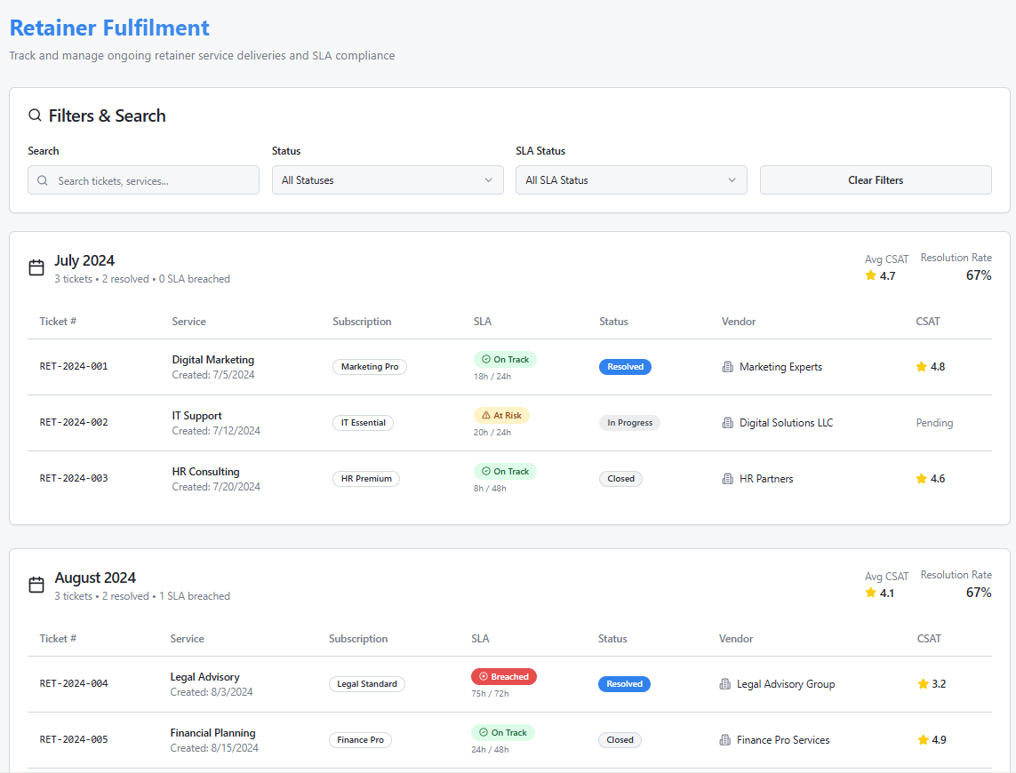

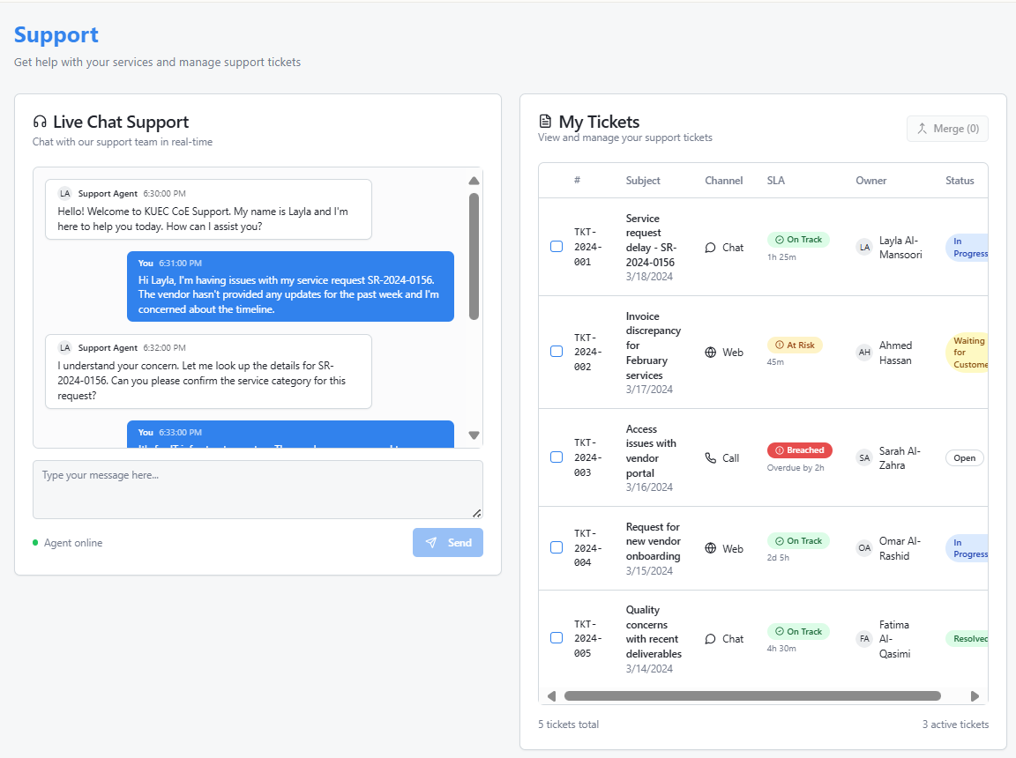
Figure 9 — Customer Support (Chat & Ticket Tracking)
Purpose: Integrated customer support view. Live chat transcript on left; ticket list on right with ability to merge duplicates.

Conclusion
The proposed KUEC Partner Self-Service Catalog Portal has been meticulously mapped and visualized based on the BRD and Service Catalog requirements. With the use of Odoo 18 EE as the foundation, the solution delivers an intuitive, fully integrated, and scalable platform capable of supporting all KUEC operations—from registration and vendor collaboration to invoicing and reporting. Each core requirement has been addressed through Odoo's out-of-the-box capabilities, with additional customization and integration planned where necessary to meet specific needs.
Key Points:
- Optimized Solution: The solution leverages Odoo's full capabilities, ensuring minimal development time while maximizing functional benefits, particularly in the areas of registration, customer service, and financial management.
- Realistic Visualizations: High-fidelity mockups allow KUEC stakeholders to easily visualize the end-user experience and the impact on their operations.
- Scalable Roadmap: Future-proof integrations (e.g., AI routing, Power BI analytics) are seamlessly aligned to Odoo’s extensible framework, providing a growth path for the portal.
- Training and Support: The training approach ensures that KUEC’s teams—ranging from vendors to internal departments—are equipped with the skills and knowledge to operate the portal efficiently from day one.
In summary, this proposal outlines how Ankabut will work collaboratively with KUEC to implement a robust, efficient, and future-oriented self-service portal, leveraging Odoo 18 EE and enhancing it with necessary customizations. This will not only fulfill immediate operational requirements but will also lay the foundation for sustained growth, efficiency, and innovation within KUEC’s shared service model.

Project Management Methodology

Project and Quality Management

Work Methodologies

ANKABUT follows a structured Software Development Lifecycle (SDLC) and project management methodology aligned with internationally recognized best practices.
ANKABUT applies the Incremental Development Process Model, in which the solution is developed through a series of prioritized increments. Each increment addresses a defined portion of the overall requirements, enabling progressive delivery of functional components in alignment with KUEC’s priorities. Upon completion, each increment is integrated and validated to ensure full functionality. This approach allows KUEC to monitor progress and test critical features throughout the project lifecycle.

Project Management Approach and Plan

ANKABUT’s project management approach follows five key phases: Initiation, Planning, Implementation, Testing & Stabilization, and Closure. Each phase is clearly defined associated with deliverables and responsibilities to ensure alignment with KUEC’s goals and expectations.



Release & Closure
- Go Live
- Training & Handover
- Documentation
5
Implementation
- System Provision
- core setup
- Application build
3
1
Initiation
- Kick-off meetings
- Stakeholder alignment



2

Test & Stabilize
- UAT
- Issue resolution
- Performance verification

Planning
- Finalize scope
- Communication plan
- Risk Planning
4

Project Governance

The project will follow a formal governance structure to ensure effective decision-making, timely risk mitigation, and continuous alignment with KUEC’s objectives. The governance framework is detailed in the following subsections.

Project Communication

Effective communication is critical to project success. The following mechanisms will be established:
- Communication Plan – Outlines frequency, audience, content, and responsible parties for internal and external communications. Developed jointly by ANKABUT and KUEC during the planning phase.
- Status Reports – Prepared and shared regularly by ANKABUT based on the communication plan, detailing project progress, risks, and upcoming milestones.
- Status Meetings – Scheduled at regular intervals to review deliverables, risks, and decisions requiring stakeholder input.

Risk Management

Risk Management is a structured process for identifying, tracking, and mitigating risks in IT projects. It aims to minimize negative impacts and maximize opportunities, though risks cannot be eliminated. Clear risk thresholds for escalations will be identified, ensuring that potential risks are addressed proactively and a pre-defined risk mitigation plan template that outlines potential mitigation strategies for common risks will be developed for the same.

This procedure ensures risks are resolved or mitigated effectively without harming the project. Identified risks are assessed and addressed during regular meetings, with any risks noted during the proposal phase carried forward into project planning for active management.
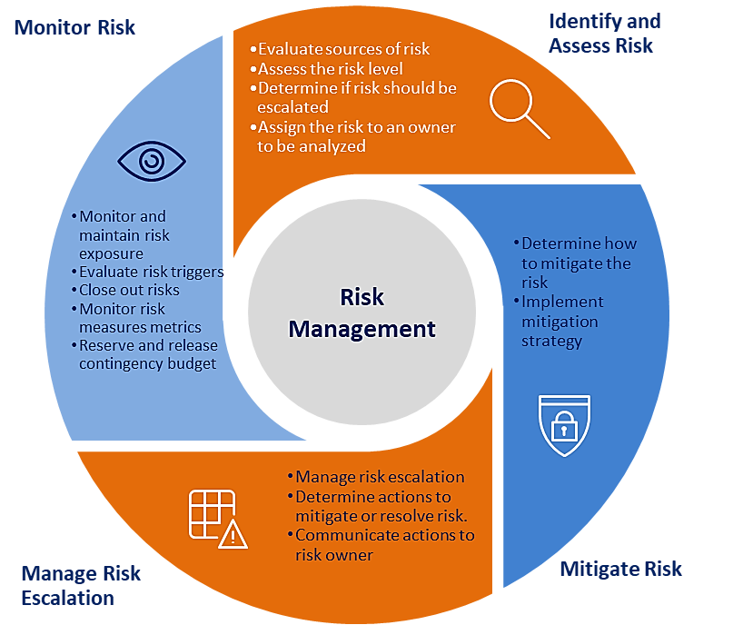

A Risk is viewed in two dimensions:
- Risk Probability - the likelihood that a certain risk will negatively affect a project
- Risk Severity - measures the anticipated impact of such a risk

Risk Mitigation Strategy
This strategy includes details for:
- Identifying and logging risks
- Prioritizing risks, including establishing clear guidelines and definitions for discrete risk priorities (for example, showstopper/executive, high, medium, low, etc.)
- Assigning risks to person(s) responsible for performing impact analysis as required
- Tracking and reporting risks status (for example, probability, impact, mitigation, planned response, symptoms, etc.)
- A structured risk management process including the following components:
- Risk Identification and Assessment
- Risk Mitigation
- Risk Management
- Risk Monitoring

Risk Mitigation Procedure
IT project risks can be identified by any stakeholder, including team members, clients, integrators, or vendors. Significant risks should be detailed in a Risk Form and logged in the Risk Log with their type, priority, and estimated resolution date. A pre-defined risk mitigation plan template will be designed that outlines potential mitigation strategies for common risks.

The project manager will review and update the Risk Log as needed, assigning each risk an owner for ongoing monitoring. Mitigation follows the established plans, with regular monitoring to address early signs of materializing risks. If symptoms arise, the response plan is executed. Regular risk assessments should follow this structured approach as required.

- Revisit risks defined at Project Start Up and include new risks as appropriate
- Categorize, assess and analyze the probability and severity of each risk
- Determine symptoms that would indicate that risks may be occurring
- Prepare a mitigation and response plan for each risk

Risk/Challenges | Recommendations for Risk Mitigation
Scope Control | - Put (stake in the ground) ---Fully define and publish scope.  - Establish an agreed-upon change control process.  - Any changes Must be approved by senior management/ steering committee
Senior Management Commitment | - Require client involvement in all functional and technical decisions.  - Establish Steering Committee comprising Senior Management Executives must be active in project.  - Key Business executive must own the business processes.
Standardization of Business Process | - Design processes that incorporate recommended practice across the organization.  - Include business process owner/representatives from each organizational entity on common process design team.  - Obtain buy-in from each organizational entity for common design.
Availability of Organization Resources | - Participant will be identified by business leaders.  - Core team members will be committed by senior management on a full basis.  - Other resources will be identified and be available on an as needed basis.
Ability to absorb change | - Develop a means of communications to keep users informed of forthcoming changes.  - Conduct walkthroughs with users at key points to provide information on product.  - Strictly follow the planned Change Management procedure throughout the project.
End-User Preparation | - Develop an effective Deployment / Roll-Out Strategy requiring consistent involvement throughout the organization.  - Provide well-timed, effective user and technical training.

Change Management Process

Any changes to the defined project scope or services must follow a formal change management process to ensure alignment with KUEC’s expectations and minimize disruptions.
The change management process steps are:
- The change is documented: all change requests will be documented in the change request form and submitted to KUEC. The change request form includes:
  - A description of the change.
  - The estimated effect of implementing the change.
- The change is submitted: the change request form will be provided to KUEC.
- The change is accepted or rejected: KUEC has three business days to confirm the following to ANKABUT
  - Acceptance— KUEC will formally approve and sign the change request form, authorizing ANKABUT to proceed with the modification.
  - Rejection- if KUEC does not want to proceed with the change or does not provide an approval within three business days, no changes will be performed.

Escalation Path

ANKABUT project manager will work closely with KUEC project manager, sponsor, and other designees to manage project issues, risks, and change requests as described previously. KUEC will provide reasonable access to ANKABUT staff to expedite resolution. The standard escalation path for review, approval, or dispute resolution is as follows:
- Project team member (ANKABUT or KUEC)
- Project manager (ANKABUT or KUEC)
- ANKABUT Delivery manager
- ANKABUT and KUEC project sponsor

Testing Management

Testing is conducted to ensure that the implemented solution/ supplied items…etc. operate correctly according to the configured design/ solution. The Test Management Plan outlines the overall strategy for performing the testing activity.

The Testing Strategy defines the approach of testing for the project, considering all characteristics, project timeline, and budget. It determines the scope and depth of testing efforts, guiding tasks such as test planning, test type selection, script development, and execution.

UAT Phase

To validate the design, implementation, and configuration of the deployed infrastructure to ensure:
- Functional correctness.
- Performance under expected workloads.
- Compliance with customer requirements and project deliverables.

Scope of Testing

Testing will cover all key components of the infrastructure that is proposed implemented as part of the proposal.
- Testing Approach
- Planning and Preparation
- Develop test cases for infrastructure components based on the HLD and LLD.
- Define testing criteria, success metrics, and roles/responsibilities.

Additional Testing Requests:

Any additional testing beyond the initial scope that impacts project timelines or milestones will follow Ankabut’s change control process. Such requests will only proceed after mutual agreement between Ankabut and KUEC project managers.

Testing Approach

- Hardware Verification: Validate that hardware components (e.g., servers, storage, and network devices) are installed correctly and operational.
- Connectivity Testing: Ensure all devices are properly connected and can communicate as per the design (e.g., IP addressing, VLANs, routing).
- Configuration Validation: Verify that all system, network, and storage configurations align with the Low-Level Design (LLD).
- Failover and Redundancy: Test high-availability setups, redundancy mechanisms, and failover scenarios (e.g., RAID, HA clusters).
- Performance Testing: Measure throughput, latency, and IOPS for systems, networks, and storage under load.
- Integration Testing: Validate end-to-end functionality of the integrated systems (e.g., storage connected to servers over the network).
- Security Testing: Verify the implementation of security policies (e.g., firewalls, ACLs, encryption).
- User Acceptance Testing (UAT)Ensure the infrastructure meets business requirements and is ready for deployment.
  - Defect Management
  - Identify and prioritize issues.
  - Resolve defects and retest affected areas.
  - Monitoring and Reporting
  - Use monitoring tools (e.g., SNMP, Syslog, and dashboards) to verify stability during testing.
  - Document test outcomes and provide a detailed report to stakeholders.
  - Sign-Off
  - Obtain formal acceptance from KUEC upon successful completion of testing.

Project Schedule (Initial Plan and Timescale)

Below is a high-level plan for the project, and a detailed project plan will be submitted prior to the project commencement. The project plan can then be finalized in consultation with the business and project management teams of KUEC

Roles & Responsibilities

ANKABUT Roles & Responsibilities
- Providing high quality services as specified in the scope and related service catalog and ensuring periodic review of the service performance.
- Providing regular reports and updates to the Client regarding the project progress.
- Providing support and Service Management as per the best practices and international standards.

Client Roles & Responsibilities
- Provide other software licenses and related and third-party support subscriptions for all the systems being managed by ANKABUT team.
- Provide hardware warranty and related support subscriptions for all the equipment owned by KUEC.
- Providing access on campuses, computing resources and workspace to facilitate ANKABUT and its subcontractor’s staff performing the maintenance and/or support.
- Reporting any issue or service request using the agreed communication channels and escalation levels mentioned in this document.
- Providing all the software licenses and hardware warranties for all the systems managed under this contract

Change Request (CR) Management

Any modifications or enhancements to the scope of work, deliverables, or timelines after the proposal has been signed shall be managed through a formal Change Request (CR) process. All change requests must be submitted in writing and are subject to review, impact assessment, and approval by both parties. Please note that approved change requests may involve additional cost and extended delivery timelines, which will be communicated and agreed upon prior to implementation

Service Maintenance

- ANKABUT will perform regular service maintenance which might cause service interruptions.
- Planned Outage: For maintenance activities that require downtime/service interruption, ANKABUT will send a notification to the Customer at least three days before the planned implementation time. The notification will be sent via email and will include a detailed description of the activity and the expected duration of the downtime/service interruption.
- Unplanned Outage: in case of any unplanned outage/service interruption, ANKABUT will send a notification to the Customer via email, which include the details of the outage and expected resolution time. Another notification will be sent once the services are restored.

Contacts & Escalations

ANKABUT Service Desk Contact Channels
There are four options available to contact ANKABUT Service Desk
Office Location | ANKABUT Offices, 1st Floor, Khalifa University Main Campus, Abu Dhabi
Phone | +971 2 3125000
Email | servicedesk@ANKABUT.ae
Web Portal | https://reach2.ANKABUT.ac.ae/

Escalations

Escalation Level | Person/Group
Level 1 | ANKABUT Service Desk
Level 2 | Service Delivery and Support Manager
Level 3 | Director of Technology Operations
Level 4 | ANKABUT CEO

